PHASE I

ENVIRONMENTAL SITE ASSESSMENT

No Name Gas
625 Hilliard Rome Rd, Columbus, Ohio, 43228

Prepared for
ACME Oil & Gas

Prepared by

Plan B Environmental
366 N 6th Street
Columbus, Ohio
43215

Report Date
2022-11-10

Project Number
2022-10-123

2022-11-10
Ref. No. 2022-10-123
ACME Oil & Gas
350, 55th Street
Houston, Texas
78654

Attention: ACME Oil & Gas
Re: Phase I Environmental Site Assessment Report
No Name Gas, 625 Hilliard Rome Rd, Columbus, Ohio, 43228

Plan B Environmental is pleased to submit our report describing the findings of the Phase I Environmental Site Assessment (ESA) of No Name Gas. This assessment was prepared in general accordance with the American Society of Testing and Materials (ASTM) Standard Practice for Environmental Site Assessments: Phase I Environmental Site Assessment Process (ASTM Designation: E1527-21).
The purpose of the Phase I ESA was to identify, to the extent feasible, recognized environmental concerns in connection with the property; and where applicable, providing the level of knowledge necessary to satisfy the innocent purchaser defense under CERCLA. This assessment included a site reconnaissance as well as research and interviews with representatives of the public, property management, and regulatory agencies.
If you have any questions or require further clarification of the report findings, please contact the undersigned at your convenience. Thank you for the opportunity to be of service to ACME Oil & Gas.

Yours very truly,
Plan B Environmental
John Smith, P.Eng.  Sr. Environmental Engineer | David Doe, P.Eng.  Engineering Manager

TABLE OF CONTENTS

1.0 EXECUTIVE SUMMARY 1
1.1 Findings and Opinions 1
1.2 Conclusions 2
2.0 INTRODUCTION 3
2.1 Location and Legal Description 3
2.2 Purpose 3
2.3 Contractual Details 3
2.4 Significant Assumptions 3
2.5 Limitations and Exceptions 4
2.6 Special Terms and Conditions 4
2.7 User Reliance 5
3.0 USER PROVIDED INFORMATION 5
3.1 Title Records 5
3.2 Environmental Liens or Activity and Use Limitations 5
3.3 Specialized Knowledge 5
3.4 Commonly Known or Reasonably Ascertainable Information 5
3.5 Valuation Reduction for Environmental Issues 6
3.6 Owner, Property Manager and Occupant Information 6
3.7 Reason for Performing Phase I ESA 6
3.8 Other Documents 7
4.0 RECORDS REVIEW 8
4.1 Standard Environmental Records 8
4.1.1 Federal Environmental Records 8
4.1.2 State and Tribal Environmental Records 9
4.2 Additional Environmental Record Sources 9
4.3 Physical Setting Source(s) 9
4.4 Historical Use Information on the Property 9
4.5 Historical Use Information on Adjoining Properties 10
4.6 Historical Use Information on Surrounding Properties 11
5.0 SITE RECONNAISSANCE 11
5.1 General Site Setting 11
5.1.1 Site and Vicinity General Characteristics 11
5.1.2 Current Use(s) of the Property 11
5.1.3 Past Use(s) of the Property 11
5.1.4 Current Use(s) of Adjoining Properties 12
5.1.5 Past Use(s) of Adjoining Properties 12
5.1.6 Current or Past Uses in the Surrounding Area 12
5.1.7 Geologic, Hydrogeologic, Hydrologic, and Topographic Conditions 12
5.1.8 General Description of Structures 13
5.1.9 Roads 13
5.1.10 Potable Water Supply 13
5.1.11 Sewage Disposal System 13
5.2 Interior and Exterior Observations 13
5.2.1 Hazardous Substances and Petroleum Products in Connection with Identified Uses 13
5.2.2 Storage Tanks 14
5.2.3 Odors 14
5.2.4 Pools of Liquid 14
5.2.5 Drums, Totes, and Containers 14
5.2.6 PCBs 15
5.3 Interior Observations 15
5.3.1 Heating/Cooling 15
5.3.2 Stains or Corrosion 15
5.3.3 Drains and Sumps 15
5.4 Exterior Observations 15
5.4.1 Pits, Ponds, or Lagoons 15
5.4.2 Stained Soil or Pavement 15
5.4.3 Stressed Vegetation 15
5.4.4 Solid Waste 16
5.4.5 Wastewater 16
5.4.6 Wells 16
5.4.7 Septic Systems 16
6.0 INTERVIEWS 16
6.1 Interviews with Client, Site Manager and Occupants 16
6.2 Interviews with State and/or Local Government Officials 16
6.3 Interviews with Past and Present Owners and Others 17
7.0 EVALUATION 17
7.1 Findings and Opinions 17
7.2 Conclusions 18
7.3 Additional Investigation 18
7.4 Additional Services 18
7.5 Limiting Conditions/Deviations 18
7.6 References 18
7.7 Signatures of Environmental Professionals 19
APPENDIX 1 SITE PLANS 20
APPENDIX 2 AERIAL (SATELLITE) PHOTOGRAPHS 24
APPENDIX 3 SITE PHOTOGRAPHS 29
APPENDIX 4 HISTORICAL RESEARCH DOCUMENTATION 31
APPENDIX 5 REGULATORY RECORDS DOCUMENTATION 33
APPENDIX 6 INTERVIEW DOCUMENTATION 35
APPENDIX 7 OTHER SUPPORTING DOCUMENTATION 66
APPENDIX 8 QUALIFICATIONS 68

EXECUTIVE SUMMARY

ACME Oil & Gas engaged Plan B Environmental to conduct a Phase I Environmental Site Assessment (ESA) of the property No Name Gas located at 625 Hilliard Rome Rd, Columbus, Ohio, 43228 subsequently referred to in this report as "the property". This assessment was prepared in general accordance with the American Society of Testing and Materials (ASTM) Standard Practice for Environmental Site Assessments: Phase I Environmental Site Assessment Process (ASTM Designation: E1527-21).

The purpose of the Phase I ESA was to identify, to the extent feasible, recognized environmental conditions in connection with the property; and where applicable, providing the level of knowledge necessary to satisfy the innocent purchaser defense under CERCLA. This assessment included a site reconnaissance as well as research and interviews with representatives of the public, property management, and regulatory agencies.

The subject property consists of a Gasoline dispensing station and convenience store. Zoning of the subject property is C1.

The current property use is gasoline retail services.

No other services beyond the requirements of Practice E1527 are required.

Findings and Opinions

The results of this assessment have revealed the following known recognized environmental conditions associated with the property:

Reported leak from UST piping system in 1995.

It is our professional opinion that the impact on the property of the known or suspected recognized environmental conditions identified in the Findings section of this report is:

Petroleum leaked during piping system upgrade in 1995 could have impacted surrounding soil and potentially the groundwater.

The results of this assessment have revealed no known controlled recognized environmental conditions associated with the property.

The results of this assessment have revealed no historical recognized environmental conditions associated with the property.

The results of this assessment have revealed no de minimis conditions associated with the property.

There were no data gaps that significantly affected our ability to identify recognized environmental conditions associated with the property.

1.2 Conclusions

This assessment has revealed recognized environmental conditions, controlled recognized environmental conditions, or significant data gaps in connection with the subject property.

INTRODUCTION

ACME Oil & Gas engaged Plan B Environmental to conduct a Phase I Environmental Site Assessment (ESA) of the property No Name Gas located at 625 Hilliard Rome Rd, Columbus, Ohio, 43228 subsequently referred to in this report as "the subject property". This assessment was prepared in general accordance with the American Society of Testing and Materials (ASTM) Standard Practice for Environmental Site Assessments: Phase I Environmental Site Assessment Process (ASTM Designation: E1527-21).

Location and Legal Description

The subject property is located at 625 Hilliard Rome Rd, Columbus, Ohio, 43228 and consists of a Gasoline dispensing station and convenience store. It is approximately 1.1 acres in size and rectangular in shape. The legal description of the subject property is Section 17, Lot 643, Parcel 23.

Purpose

The purpose of the Phase I ESA was to identify, to the extent feasible pursuant to the processes prescribed herein, recognized environmental concerns in connection with the property. This assessment included a site reconnaissance, records review, as well as research and interviews with representatives of the public, property management, and regulatory agencies.

Contractual Details

The scope of work for this assessment was in general accordance with the American Society of Testing and Materials (ASTM) Standard Practice for Environmental Site Assessments: Phase I Environmental Site Assessment Process (ASTM Designation: E1527-21). These methodologies are described as representing good commercial and customary practice for conducting an ESA of a property for the purpose of identifying recognized environmental conditions (RECs). The term recognized environmental conditions means the presence or likely presence of any hazardous substances or petroleum products in, on, or at a property: (1) due to any release to the environment; (2) under conditions indicative of a release to the environment; or (3) under conditions that pose a material threat of a future release to the environment. De minimis conditions are not recognized environmental conditions.

Significant Assumptions

While this report provides an overview of potential environmental concerns, both past and present, the environmental assessment is limited by the availability of information at the time of the assessment. It is possible that unreported disposal of waste or illegal activities impairing the environmental status of the property may have occurred which could not be identified. The conclusions and recommendations regarding environmental conditions that are presented in this report are based on a scope of work authorized by the Client. Note, however, that virtually no scope of work, no matter how exhaustive, can identify all contaminants or all conditions above and below ground.

Limitations and Exceptions

The report has been prepared in accordance with generally accepted environmental methodologies referred to in ASTM E1527-21 and contains all of the limitations inherent in these methodologies. No other warranties, expressed or implied, are made as to the professional services provided under the terms of our contract and included in this report.

The conclusions of this report are based in part, on the information provided by others. The possibility remains that unexpected environmental conditions may be encountered at the site in locations not specifically investigated. Should such an event occur, Plan B Environmental must be notified in order that we may determine if modifications to our conclusions are necessary.

The services performed and outlined in this report were based, in part, upon visual observations of the site and attendant structures. Our opinion cannot be extended to portions of the site that were unavailable for direct observation, reasonably beyond the control of Plan B Environmental.

The objective of this report was to assess environmental conditions at the site, within the context of our contract and existing environmental regulations within the applicable jurisdiction. Evaluating compliance of past or future owners with applicable local, provincial, and federal government laws and regulations was not included in our contract for services.

Our observations relating to the condition of environmental media at the site are described in this report. It should be noted that compounds or materials other than those described could be present in the site environment.

No environmental site assessment can wholly eliminate uncertainty regarding the potential for recognized environmental conditions in connection with a property. Performance of this assessment is intended to reduce, but not eliminate uncertainty regarding the potential for recognized environmental conditions in connection with the property recognizing reasonable limits of time and cost.

This assessment does not include any testing or sampling of materials (for example, soil, water, air, building materials).

Special Terms and Conditions

No special terms and conditions were agreed on between the client and the environmental professional.

No parties to the property transaction have a required standard scope of services.

No other services beyond the requirements of Practice E1527 are required.

No other parties will rely on the Phase I ESA report.

User Reliance

This report may be distributed and relied upon by ACME Oil & Gas, its successors, and assigns. Reliance on the information and conclusions in this report by any other person or entity is not authorized without the written consent of Plan B Environmental.

USER PROVIDED INFORMATION

Title Records

The client engaged LT Search Inc. to review recorded land title records and lien records.
The user relied on Transaction-Related Title Insurance Documentation for the land title search.

The results of the title review were:

Property was purchased by NoBrand Gas in 1997.

Environmental Liens or Activity and Use Limitations

The user is not aware of any land title records identifying any environmental liens against the property that are filed or recorded under federal, tribal, state, or local law.

The user is not aware of any land title records identifying any AULs, such as engineering controls, land use restrictions or institutional controls that are in place at the site and/or have been filed or recorded against the property.

Specialized Knowledge

The user does not have any specialized knowledge or experience related to the property or nearby properties.

Commonly Known or Reasonably Ascertainable Information

The user does not know the past uses of the property.

The user does not know of any specific chemicals that are present or once were present at the property.

The user does not know of any spills or other chemical releases that have taken place at the property.

The user does not know of any environmental cleanups that have taken place at the property.

The user knows of no indicators that point to the presence or likely presence of contamination at the property.

The user does not know of any litigation relevant to hazardous substances or petroleum products in, on, or from the property.

The user does not know of any administrative proceedings relevant to hazardous substances or petroleum products in, on, or from the property.

The user does not know of any notices regarding possible violation of environmental laws or possible liability relating to hazardous substances or petroleum products.

The user does not have any other knowledge or experience with the property that may be pertinent to the environmental professional.

Valuation Reduction for Environmental Issues

The user believes the purchase price being paid for this property reasonably reflects the fair market value of the property.

Owner, Property Manager and Occupant Information

The client is not the current owner.

The current owner is No Name Gas.

The property is currently occupied by:

No Brand Gas

Dave Olivier was identified as the Key Site Contact of the property.

Reason for Performing Phase I ESA

The Phase 1 ESA was prepared by Plan B Environmental at the request of Client. This Phase 1 ESA was requested for the following reasons:

Assist in the evaluation of the subject property's overall development potential.

Other Documents

The user does not know if there are environmental site assessment reports on the property that can be provided for review within reasonable time and cost constraints.

The user does not know if there are environmental compliance audit reports on the property that can be provided for review within reasonable time and cost constraints.

The user does not know if there are environmental site investigation reports on the property that can be provided for review within reasonable time and cost constraints.

The user does not know if there are environmental permits on the property that can be provided for review within reasonable time and cost constraints.

The user does not know if there are registrations for underground and above-ground storage tanks on the property that can be provided for review within reasonable time and cost constraints.

The user does not know if there are registrations for underground injection systems on the property that can be provided for review within reasonable time and cost constraints.

The user does not know if there are material safety data sheets on the property that can be provided for review within reasonable time and cost constraints.

The user does not know if there is a community right-to-know plan for the property that can be provided for review within reasonable time and cost constraints.

The user does not know if there are safety plans; preparedness and prevention plans; spill prevention, countermeasure, and control plans; facility response plans, etc. for the property that can be provided for review within reasonable time and cost constraints.

The user does not know if there are reports regarding hydrogeologic conditions on the property or surrounding area that can be provided for review within reasonable time and cost constraints.

The user does not know if there are any reports regarding self-directed or other cleanup activities on the property that can be provided for review within reasonable time and cost constraints.

The user does not know if there are notices or other correspondence from any government agency relating to past or current violations of environmental laws or liens with respect to the property.

The user does not know if there are hazardous waste generator notices or reports on the property that can be provided for review within reasonable time and cost constraints.

The user does not know if there are geotechnical studies on the property that can be provided for review within reasonable time and cost constraints.

The user does not know if there are risk assessments on the property that can be provided for review within reasonable time and cost constraints.

The user does not know if there are recorded AULs on the property that can be provided for review within reasonable time and cost constraints.

RECORDS REVIEW

The purpose of the records review was to obtain and review records that will help identify recognized environmental concerns in connection with the property.

Some records reviewed pertain not only to the property, but also to properties within an additional approximate minimum search distance to help assess the likelihood of problems from migrating hazardous substances or petroleum products. Unless stated otherwise the approximate minimum search distances used below were as specified in the ASTM Standard E1527-21.

Standard Environmental Records

A search of available federal and state environmental records was obtained from FirstSearch Technology Corporation (FirstSearch) of Indianapolis, Indiana. A copy of this search is provided in Appendix B. The environmental records were requested on 2022-10-17. The environmental records were last updated by the environmental record provider on 2020-07-12.

Due to discrepancies in the location of some facilities in the databases arising from incorrect or incomplete addresses some facilities may be listed as un-mappable. No unmappable facilities were observed to be within the ASTM minimum search distance of the subject property.

A review of the regulatory information from this database search for possible recognized environmental conditions (RECs) within the ASTM approximate minimum search distance is provided in the Federal and State sections below.

Federal Environmental Records

Record Source | Within Property | Adjoining Property
NPL (Superfund) sites | None | None
Delisted NPL sites | None | None
Sites subject to CERCLA removals and orders | None | None
CERCLA sites with NFRAP | None | None
RCRA facilities undergoing corrective action | None | None
RCRA TSD Facilities | None | None
RCRA Generators | None | None
Institutional/Engineering Controls registries | None | None
ERNS list | None | None

State and Tribal Environmental Records

Record Source | Within Property | Adjoining Property
Superfund equivalent sites | None | None
Hazardous waste facilities | None | None
Landfills/solid waste disposal facilities | None | None
Leaking storage tanks | A confirmed release was reported on June 4, 1995 during a UST piping system upgrade. | None
Registered storage tanks | 2 | None
Institutional/engineering control registries | None | None
Voluntary cleanup sites | None | None
Brownfield sites | None | None

Additional Environmental Record Sources

The following records were reviewed from other agencies:

Clifford City Directories

Physical Setting Source(s)

A current USGS 7.5 Minute Topographic Map, 1985 Ohio 7.5 minute was reviewed to determine the physical setting of the property. Property is approximately 350 feet above sea level with a moderate slope to the south. Pringle Creek is approximately 100 feet to the east.

A bedrock map for the subject property was reviewed. Bedrock consists of Canadian series of marine carbonates.

The following other physical setting data was reviewed:

USDA map indicates soil on the property is Urban Land Complex.

Historical Use Information on the Property

The objective of consulting historical sources is to develop a history of the previous uses of the property to help identify the likelihood of past uses having led to recognized environmental conditions in connection with the property. Historical use formation describing the subject property was obtained from a variety of sources as discussed below. This information is summarized in the table below.

Period/Date | Land Use | Source(s) of Information
1926 | Farm | City Directories
1934 | Vegetable stand | City Directories
1946 | Gasoline dispensing station | Aerial photos
1950 | Gasoline dispensing station | Aerial photos
1980 | Gasoline dispensing station and convenience store | Aerial photos

Historical Use Information on Adjoining Properties

The objective of consulting historical sources is to develop a history of the previous uses of the surrounding properties to help identify the likelihood of past uses having led to recognized environmental conditions in connection with the property. The historical uses of adjoining properties to the subject property are summarized below. These uses were determined using the standard historical sources noted above.

North Historical Land Use

Period/Date | Land Use | Source(s) of Information
1927 | Farm | City Directories
1956 | Convenience store | Aerial Photos
1978 | Fast Food Restaurant | Aerial Photos

South Historical Land Use

Period/Date | Land Use | Source(s) of Information
1924 | Farm | City Directories
1978 | Offices | Aerial Photos

East Historical Land Use

Period/Date | Land Use | Source(s) of Information
1924 | Farm | City Directories
1967 | Gasoline Station | Aerial Photos

West Historical Land Use

Period/Date | Land Use | Source(s) of Information
1932 | Farm | City Directories
1982 | Storage Units | Aerial Photos

Historical Use Information on Surrounding Properties

The historical uses of surrounding properties were not identified.

SITE RECONNAISSANCE

The purpose of the site reconnaissance is to obtain information indicating the likelihood of identifying recognized environmental conditions in connection with the property.

The subject property was inspected on 2022-10-27. The assessor was accompanied by Dan Brown, Operations Supervisor during the inspection. The weather during the inspection was sunny with a light wind from the east.

All areas of the subject property were accessible at the time of the inspection. There were no visual or physical obstructions of the subject property.

During the inspection an exterior and interior walk-through of the buildings, if present, was performed. The exterior of adjoining properties was visually evaluated for any recognized environmental concerns (RECs).

General Site Setting

Site and Vicinity General Characteristics

The area is zoned as C1. The general area of the property is used for residential and light commercial.

Current Use(s) of the Property

The current property use is gasoline retail services.

The following Recognized Environmental Concerns (RECs) may be associated with the current property use:

previously reported LUST

Past Use(s) of the Property

The past use of the property was:

farm and vegetable stand

There are no RECs associated with the past property use.

Current Use(s) of Adjoining Properties

The current uses of the adjoining properties are:

North: | Fast Food Restaurant
South: | Offices
East: | Gasoline Station
West: | Storage Units

The following recognized environmental concerns (RECs) were identified on the adjoining properties:

North: | None
South: | None
East: | None
West: | None

Past Use(s) of Adjoining Properties

The past uses of the adjoining properties are:

North: | farm
South: | farm
East: | farm
West: | farm

The following recognized environmental concerns (RECs) from past uses were identified on the adjoining properties:

North: | None
South: | None
East: | None
West: | None

Current or Past Uses in the Surrounding Area

The area is zoned as C1. The general area of the property is used for residential and light commercial.

5.1.7 Geologic, Hydrogeologic, Hydrologic, and Topographic Conditions

The topography of the property is relatively flat with a moderate slope to the south. The topography of the surrounding area is slightly rolling with a gentle slope to the south.

Hazardous substances or petroleum products are not likely to be present on nearby properties and not likely to migrate to the property.

Based on the topography and likely presence of hazardous substances or petroleum products on the property there is a possibility that these substances could migrate from the property to the groundwater or soil. Petroleum products from LUST could migrate to soil surrounding storage tanks and to nearby creek.

General Description of Structures

The following buildings and structures are located on the subject property:

Age (years) | Stories | Usage | Construction
22 | 1 | convenience store

Roads

There are no roads on the property.

The following parking facilities are located on the property:

12 parking spots beside convenience store

No public thoroughfares adjoin the property.

Potable Water Supply

Potable water on the property is supplied by the municipal water supply.

Sewage Disposal System

Sanitary sewage is discharged into municipal sanitary sewer system. The age of the sewage disposal system could not be determined.

Interior and Exterior Observations

Hazardous Substances and Petroleum Products in Connection with Identified Uses

No hazardous materials were observed to be stored or used on the property in connection with identified uses.

Storage Tanks

Determining the presence of Aboveground Storage Tanks (ASTs) and Underground Storage Tanks (USTs) is considered essential in assessing potential contamination sources. Visual inspection and the review of tank registration records are used to determine the possible existence of past and present storage tanks in the area of the subject property. It must be noted however, that the absence of certain site conditions or lack of records may restrict or prevent the determination of the number and contents of storage tanks on the subject property.

No aboveground storage tanks were observed on the subject property.

Underground storage tanks that may contain hazardous chemicals or fuel were observed on the subject property.

The following underground storage tanks were observed:

Contents | Age (years) | Size | Location
Diesel | 8 | 8000 gallons | west side of property
Gas | 7 | 12000 gallons | west side of property

Vent, fill pipes, or access ways were observed on the subject property. These pipes may indicate the presence of un-recorded underground storage tanks. There were 2 vent and 2 fill pipes on west side of property.

Odors

No strong, pungent, or noxious odors were observed.

Pools of Liquid

No standing surface water was observed on the property.

Drums, Totes, and Containers

There are no hazardous substance and petroleum product drums, totes, and containers in connection with identified uses on the property.

There are no hazardous substance and petroleum product drums, totes, and containers not in connection with identified uses on the property.

There are no unidentified substance drums, totes, or containers on the property.

PCBs

The past use of PCBs in electrical equipment such as transformers, fluorescent lamp ballasts, and capacitors was common. PCBs in electrical equipment are controlled by United States EPA regulation 40 CFR, Part 761. According to this regulation there are three categories for classifying electrical equipment; less than 50 ppm of PCBs is considered “non-PCB”; between 50 and 500 ppm is considered “PCB-Contaminated”; and greater than 500 ppm is considered “PCB”.

No electrical or hydraulic equipment known or likely to contain PCBs were observed on the property.

Interior Observations

Heating/Cooling

The buildings on the property are heated by electric & natural gas (piped). There are no air-conditioned buildings on the property.

Stains or Corrosion

There were no stains or corrosion on the floors, walls, or ceilings in the buildings.

Drains and Sumps

No floor drains or sumps were observed in the buildings on the property.

Exterior Observations

Pits, Ponds, or Lagoons

No pits, ponds, or lagoons were observed on the property.

No pits, ponds, or lagoons were observed on adjoining properties.

Stained Soil or Pavement

No areas of stained soil were observed on the property.

The following areas of stained pavement were observed on the property:

Petroleum staining was observed adjacent to the fuel dispensers and pump islands.

Stressed Vegetation

No areas of stressed vegetation were observed on the property.

Solid Waste

No areas, mounds, or depressions that may be filled or graded by non-natural causes or filled with fill of unknown origin suggesting trash or other solid waste disposal were observed on the property.

Wastewater

There was no wastewater or other liquids being discharged from or to the subject property.

Wells

No wells were observed on the property.

Septic Systems

No septic systems or cesspools were observed on the property.

INTERVIEWS

The purpose of interview is to obtain information indicating recognized environmental conditions in connection with the property. Copies of the interview documentation can be found in Appendix 6.

Interviews with Client, Site Manager and Occupants

Date | Name | Status | Organization
2022-10-05 | Mike Johnson | Client | ACME Oil & Gas
2022-10-12 | Tom Smith | Site Manager | No Name Gas
 |  | Occupant
 |  | Occupant
 |  | Occupant
 |  | Occupant
 |  | Occupant

Interviews with State and/or Local Government Officials

Date | Name | Title | Organization
2022-10-19 | Lisa Elliot | County Clerk | District 11 Administration
2022-10-21 | Michael Moore | Sr. Environmental Officer | Ohio EPA

Interviews with Past and Present Owners and Others

Date | Name | Status | Organization
2022-10-13 | John Harvey | Current Owner | No Name Gas

EVALUATION

Findings and Opinions

The results of this assessment have revealed the following known recognized environmental conditions associated with the property:

Reported leak from UST piping system in 1995.
It is our professional opinion that the impact on the property of the known or suspected recognized environmental conditions identified in the Findings section of this report is:

Petroleum leaked during piping system upgrade in 1995 could have impacted surrounding soil and potentially the groundwater.

The results of this assessment have revealed no known controlled recognized environmental conditions associated with the property.

The results of this assessment have revealed no historical recognized environmental conditions associated with the property.

The results of this assessment have revealed no de minimis conditions associated with the property.

There were no data gaps that significantly affected our ability to identify recognized environmental conditions associated with the property.

Conclusions

We have performed a Phase I Environmental Site Assessment in conformance with the scope and limitations of ASTM Practice E152721 of 625 Hilliard Rome Rd, Columbus, Ohio, 43228, the property. Any exceptions to, or deletions from, this practice are described in Section 7.5 of this report.

This assessment has revealed recognized environmental conditions, controlled recognized environmental conditions, or significant data gaps in connection with the subject property.

Additional Investigation

In our professional opinion no additional investigation is recommended to detect the presence of hazardous substances or petroleum products and provide greater certainty regarding identified recognized environmental conditions on the property.

Additional Services

No additional services beyond the scope of the ASTM Standard 1527-21 were conducted as part of this assessment.

Limiting Conditions/Deviations

There are no limiting conditions, deletions or deviations and this Phase I ESA complies with the ASTM Standard 1527-21.

References

The following documents, maps, or other publications may have been used in the preparation of this report.

- American Society for Testing and Materials Standard Practice for Environmental Site Assessments: Phase I Environmental Site Assessment Process (ASTM E1527-13).

- American Society for Testing and Materials Guide for Environmental Site Assessments: Transaction Screen Process (ASTM E1528).

- Comprehensive Environmental Response, Compensation, and Liability Act of 1980 (“CERCLA” or “Superfund”), as amended by Superfund Amendments and Reauthorization Act of 1986 (“SARA”) and Small Business Liability Relief and Brownfields Revitalization Act of 2002 (“Brownfield Amendments”), 42 U.S.C. §§9601, et. seq.

- Resource Conservation and Recovery Act, as amended (“RCRA”), 42 U.S.C. §6901, et. seq.

- Federal Emergency Management Agency, National Flood Insurance Program, Flood Insurance Maps.

- United States Department of Agriculture, Soil Conservation Service, Soil Surveys.

- United States Geological Survey, Topographic Maps.

- United States Department of the Interior, Fish and Wildlife Service, National Wetlands Inventory Map

Signatures of Environmental Professionals

We declare that, to the best of our professional knowledge and belief, we meet the definition of Environmental Professional as defined in §312.10 of 40 CFR §312. We have the specific qualifications based on education, training, and experience to assess a property of the nature, history, and setting of the subject property. We have developed and performed all appropriate inquiries in conformance with the standards and practices set forth in 40 CFR Part 312.

Prepared by: Reviewed by:
John Smith, P.Eng.  Sr. Environmental Engineer | David Doe, P.Eng.  Engineering Manager

The qualifications of the environmental professional(s) and personnel conducting the site reconnaissance and interviews (if conducted by someone other than an environmental professional) are provided in Appendix 8.

APPENDIX 1 SITE PLANS

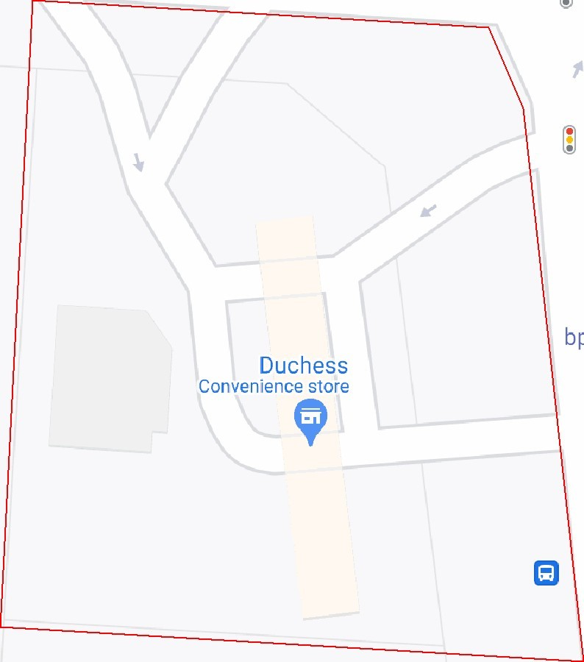
Project Location Map
Project Number:
PN123456
Project Name:
No Name Gas
Client Name:
ACME Oil and Gas
Site Location
Address:
625
Hilliard Rome Rd
City:
Columbus
State:
Ohio
Engineer:
Date:
2022-11-09
Plan B Environmental
366
N 6th Street
Columbus, OH

APPENDIX 2 AERIAL (SATELLITE) PHOTOGRAPHS

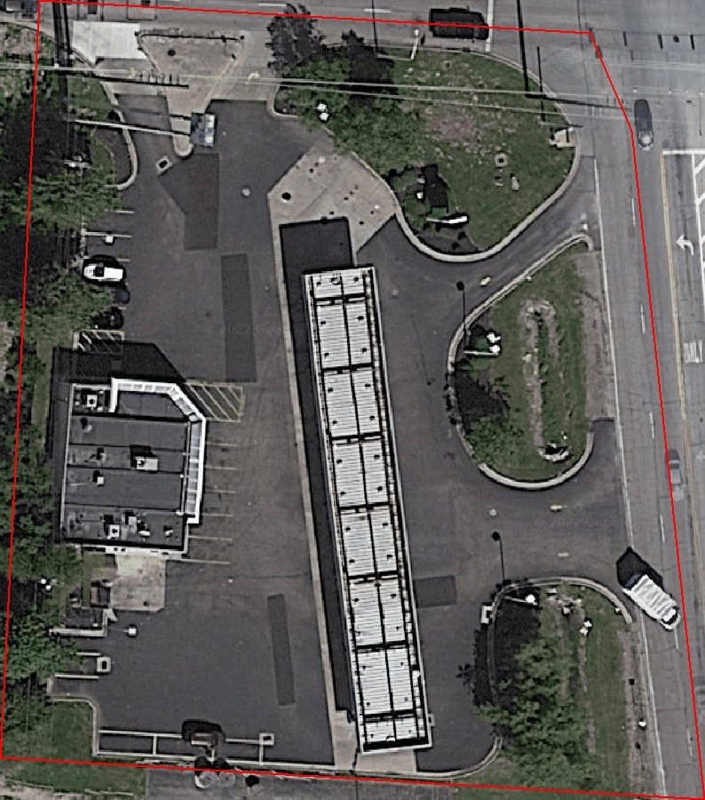
Project Location Map
Project Number:
PN123456
Project Name:
No Name Gas
Client Name:
ACME Oil and Gas
Site Location
Address:
625
Hilliard Rome Rd
City:
Columbus
State:
Ohio
Engineer:
Date:
2022-11-09
Plan B Environmental
366
N 6th Street
Columbus, OH
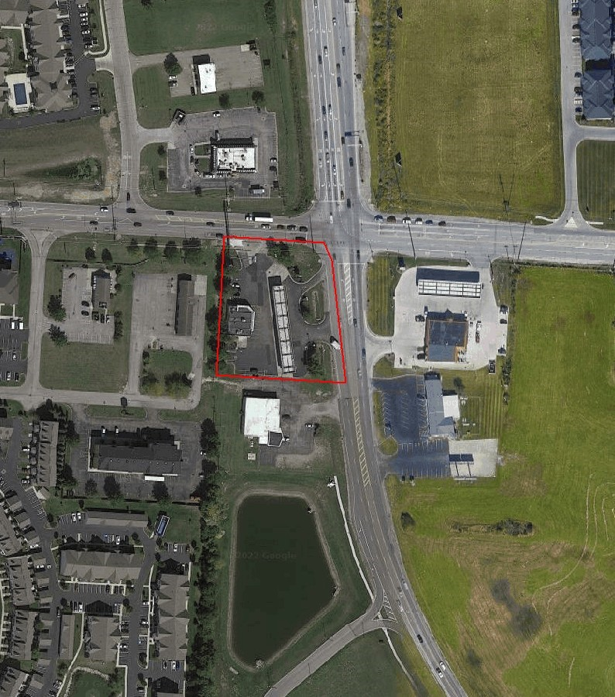
Project Location Map
Project Number:
PN123456
Project Name:
No Name Gas
Client Name:
ACME Oil and Gas
Site Location
Address:
625
Hilliard Rome Rd
City:
Columbus
State:
Ohio
Engineer:
Date:
2022-11-09
Plan B Environmental
366
N 6th Street
Columbus, OH

APPENDIX 3 SITE PHOTOGRAPHS

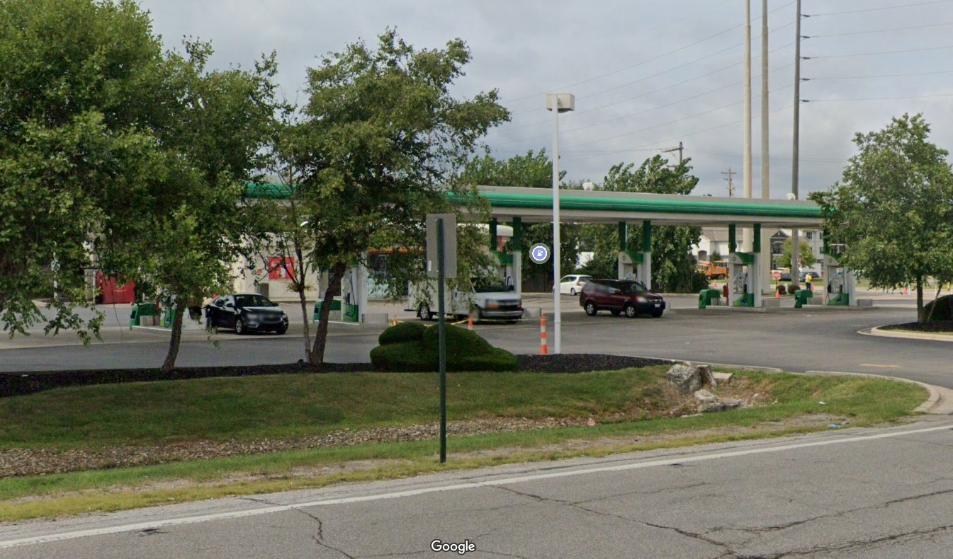

APPENDIX 4 HISTORICAL RESEARCH DOCUMENTATION

APPENDIX 5 REGULATORY RECORDS DOCUMENTATION

APPENDIX 6 INTERVIEW DOCUMENTATION

Client Questionnaire

Date of Interview: 2022-10-05
Name: Mike Johnson
Title: Environmental Manager
Organization: ACME Oil & Gas

General Questions

- What is the reason why the Phase I is required?
Assist in the evaluation of the subject property's overall development potential.
- What is the current use of the property?
Gasoline dispensing station and convenience store
- What type of property transaction is it (sale, purchase, exchange, etc.)?
Purchase
- Have you engaged a title company or professional to review recorded land title records and lien records?
The client engaged LT Search Inc. to review recorded land title records and lien records.
- What method was used for the land title search?
The user relied on Transaction-Related Title Insurance Documentation for the land title search.
- What were the results of the title review?
The results of the title review were:

Property was purchased by NoBrand Gas in 1997.
- Who is the owner of the property?
The client is not the current owner.
  - Client is Owner
    - Who is the site contact for the property?

    - How can the site contact be reached?
  - Client is Not Owner
    - Who is the current owner of the property?
The current owner is No Name Gas.
    - How can the current owner be reached?
The current owner can be reached by 204-222-1234.
- Do you know of any pending threatened, or past litigation relevant to hazardous substances or petroleum products in, on, or from the property?
The user does not know of any litigation relevant to hazardous substances or petroleum products in, on, or from the property.
- Do you know of any pending, threatened, or past administrative proceedings relevant to hazardous substances or petroleum products in, on, or from the property?
The user does not know of any administrative proceedings relevant to hazardous substances or petroleum products in, on, or from the property.
- Do you know of any notices from any government entity regarding any possible violation of environmental laws or possible liability relating to hazardous substances or petroleum products?
The user does not know of any notices regarding possible violation of environmental laws or possible liability relating to hazardous substances or petroleum products.
- Do any of the parties to the property transaction have a required standard scope of services?
No parties to the property transaction have a required standard scope of services.
- Other than yourself, what other parties will rely on the Phase I report?
No other parties will rely on the Phase I ESA report.
- Are there any special terms and conditions that must be agreed upon by the environmental professional?
No special terms and conditions were agreed on between the client and the environmental professional.
- Do you have any other knowledge or experience with the property that may be pertinent to the environmental professional (for example, copies of any available prior ESA reports, documents, correspondence, etc.)?
The user does not have any other knowledge or experience with the property that may be pertinent to the environmental professional.
- Are any services beyond the requirements of Practice E1527-21 required?
No other services beyond the requirements of Practice E1527 are required.
Landowner Liability Protection Related Questions
- Environmental cleanup liens that are filed or recorded against the site (40 CFR 312.25).
Did a search of recorded land title records identify any environmental cleanup liens against the property that are filed or recorded under federal, tribal, state, or local law?
The user is not aware of any land title records identifying any environmental liens against the property that are filed or recorded under federal, tribal, state, or local law.
- Activity and land use limitations that are in place on the site or that have been filed or recorded in a registry (40 CFR 312.26).
Did a search of land title records identify any AULs, such as engineering controls, land use restrictions or institutional controls that are in place at the site and/or have been filed or recorded against the property under federal, tribal, state, or local law?
The user is not aware of any land title records identifying any AULs, such as engineering controls, land use restrictions or institutional controls that are in place at the site and/or have been filed or recorded against the property.
- Specialized knowledge or experience of the person seeking to qualify for the LLP (40 CFR 312.28).
Do you have any specialized knowledge or experience related to the property or nearby properties? For example, are you involved in the same line of business as the current or former occupants of the property or an adjoining property so that you would have specialized knowledge of the chemicals and processes used by this type of business?
The user does not have any specialized knowledge or experience related to the property or nearby properties.
- Relationship of the purchase price to the fair market value of the property if it were not contaminated (40 CFR 312.29).
Does the purchase price being paid for this property reasonably reflect the fair market value of the property? If you conclude that there is a difference, have you considered whether the lower purchase price is because contamination is known or believed to be present at the property?
The user believes the purchase price being paid for this property reasonably reflects the fair market value of the property. _
- Commonly known or reasonably ascertainable information about the property (40 CFR 312.30).
  - Do you know the past uses of the property?
The user does not know the past uses of the property.
  - Do you know of specific chemicals that are present or once were present at the property?
The user does not know of any specific chemicals that are present or once were present at the property.
(c) Do you know of spills or other chemical releases that have taken place at the property?
The user does not know of any spills or other chemical releases that have taken place at the property.
- Do you know of any environmental cleanups that have taken place at the property?
The user does not know of any environmental cleanups that have taken place at the property.
- The degree of obviousness of the presence or likely presence of contamination at the property, and the ability to detect the contamination by appropriate investigation (40 CFR 312.31).
Based on your knowledge and experience related to the property are there any indicators that point to the presence or likely presence of contamination at the property?
The user knows of no indicators that point to the presence or likely presence of contamination at the property.

Helpful Documents Related Questions
Do you know of any of the following documents for the property exist and whether copies can be provided for review within reasonable time and cost constraints?
- Environmental site assessment reports?
The user does not know if there are environmental site assessment reports on the property that can be provided for review within reasonable time and cost constraints.
- Environmental compliance audit reports?
The user does not know if there are environmental compliance audit reports on the property that can be provided for review within reasonable time and cost constraints.
- Environmental site investigation reports?
The user does not know if there are environmental site investigation reports on the property that can be provided for review within reasonable time and cost constraints.
- Environmental permits?
The user does not know if there are environmental permits on the property that can be provided for review within reasonable time and cost constraints.
- Registrations for underground and above-ground storage tanks?
The user does not know if there are registrations for underground and above-ground storage tanks on the property that can be provided for review within reasonable time and cost constraints.
- Registrations for underground injection systems?
The user does not know if there are registrations for underground injection systems on the property that can be provided for review within reasonable time and cost constraints.
- Safety data sheets?
The user does not know if there are material safety data sheets on the property that can be provided for review within reasonable time and cost constraints.
- Community right-to-know plan?
The user does not know if there is a community right-to-know plan for the property that can be provided for review within reasonable time and cost constraints.
- Safety plans; preparedness and prevention plans; spill prevention, countermeasures and control plans; facility response plans?
The user does not know if there are safety plans; preparedness and prevention plans; spill prevention, countermeasure, and control plans; facility response plans, etc. for the property that can be provided for review within reasonable time and cost constraints.
- Reports regarding hydrogeologic conditions?
The user does not know if there are reports regarding hydrogeologic conditions on the property or surrounding area that can be provided for review within reasonable time and cost constraints.
- Reports regarding any self-directed or other cleanup activities?
The user does not know if there are any reports regarding self-directed or other cleanup activities on the property that can be provided for review within reasonable time and cost constraints.
- Notices or other correspondence from any government agency relating to past or current violations of environmental laws or liens?
The user does not know if there are notices or other correspondence from any government agency relating to past or current violations of environmental laws or liens with respect to the property.
- Hazardous waste generator notices or reports?
The user does not know if there are hazardous waste generator notices or reports on the property that can be provided for review within reasonable time and cost constraints.
- Geotechnical studies?
The user does not know if there are geotechnical studies on the property that can be provided for review within reasonable time and cost constraints.
- Risk assessments?
The user does not know if there are risk assessments on the property that can be provided for review within reasonable time and cost constraints.
- Recorded AULs?
The user does not know if there are recorded AULs on the property that can be provided for review within reasonable time and cost constraints.

Owner Questionnaire
(Only use if client is not current owner)

Date of Interview: 2022-10-13
Name: John Harvey
Title: General Manager
Organization: No Name Gas

General Questions

- How long have you owned the property?
12 years
- What is the current use of the property?
Gas station and convenience store
- Who is the site contact for the property?
Dave Olivier
- How can the site contact be reached?
225-320-1900
- Do you know the past uses of the property?
The current owner knows of the following past uses of the property:

Gas station
- Do you know of any pending threatened, or past litigation relevant to hazardous substances or petroleum products in, on, or from the property?
The current owner does not know of any litigation relevant to hazardous substances or petroleum products in, on, or from the property.
- Do you know of any pending, threatened, or past administrative proceedings relevant to hazardous substances or petroleum products in, on, or from the property?
The current owner does not know of any administrative proceedings relevant to hazardous substances or petroleum products in, on, or from the property.

- Do you know of any notices from any government entity regarding any possible violation of environmental laws or possible liability relating to hazardous substances or petroleum products?
The current owner does not know of any notices regarding possible violation of environmental laws or possible liability relating to hazardous substances or petroleum products.
- Do you know of specific chemicals that are present or once were present at the property?
The current owner does not know of any specific chemicals that are present or once were present at the property.
- Do you know of spills or other chemical releases that have taken place at the property?
The current owner does not know of any spills or other chemical releases that have taken place at the property.
- Do you know of any environmental cleanups that have taken place at the property?
The current owner does not know of any environmental cleanups that have taken place at the property.
- Do you have any other knowledge or experience with the property that may be pertinent to the environmental professional (for example, copies of any available prior ESA reports, documents, correspondence, etc.)?
The current owner does not have any other knowledge or experience with the property that may be pertinent to the environmental professional.
- Based on your knowledge and experience related to the property are there any indicators that point to the presence or likely presence of contamination at the property?
The current owner knows of no indicators that point to the presence or likely presence of contamination at the property.
Helpful Documents Related Questions
Do you know of any of the following documents for the property exist and whether copies can be provided for review within reasonable time and cost constraints?
- Environmental site assessment reports?
The current owner does not know if there are environmental site assessment reports on the property that can be provided for review within reasonable time and cost constraints.
- Environmental compliance audit reports?
The current owner does not know if there are environmental compliance audit reports on the property that can be provided for review within reasonable time and cost constraints.
- Environmental site investigation reports?
The current owner does not know if there are environmental site investigation reports on the property that can be provided for review within reasonable time and cost constraints.
- Environmental permits?
The current owner does not know if there are environmental permits on the property that can be provided for review within reasonable time and cost constraints.
- Registrations for underground and above-ground storage tanks?
The current owner does not know if there are registrations for underground and above-ground storage tanks on the property that can be provided for review within reasonable time and cost constraints.
- Registrations for underground injection systems?
The current owner does not know if there are registrations for underground injection systems on the property that can be provided for review within reasonable time and cost constraints.
- Safety data sheets?
The current owner does not know if there are material safety data sheets on the property that can be provided for review within reasonable time and cost constraints.
- Community right-to-know plan?
The current owner does not know if there is a community right-to-know plan for the property that can be provided for review within reasonable time and cost constraints.
- Safety plans; preparedness and prevention plans; spill prevention, countermeasures and control plans; facility response plans?
The current owner does not know if there are safety plans; preparedness and prevention plans; spill prevention, countermeasure, and control plans; facility response plans, etc. for the property that can be provided for review within reasonable time and cost constraints.
- Reports regarding hydrogeologic conditions?
The current owner does not know if there are reports regarding hydrogeologic conditions on the property or surrounding area that can be provided for review within reasonable time and cost constraints.
- Reports regarding any self-directed or other cleanup activities?
The current owner does not know if there are any reports regarding self-directed or other cleanup activities on the property that can be provided for review within reasonable time and cost constraints.
- Notices or other correspondence from any government agency relating to past or current violations of environmental laws or liens?
The current owner does not know if there are notices or other correspondence from any government agency relating to past or current violations of environmental laws or liens with respect to the property.
- Hazardous waste generator notices or reports?
The current owner does not know if there are hazardous waste generator notices or reports on the property that can be provided for review within reasonable time and cost constraints.
- Geotechnical studies?
The current owner does not know if there are geotechnical studies on the property that can be provided for review within reasonable time and cost constraints.
- Risk assessments?
The current owner does not know if there are risk assessments on the property that can be provided for review within reasonable time and cost constraints.
- Recorded AULs?
The current owner does not know if there are recorded AULs on the property that can be provided for review within reasonable time and cost constraints.
Site Manager Questionnaire
(Only use if client is not the site manager)

Date of Interview: 2022-10-12
Name: Tom Smith
Title: Property Manager
Organization: No Name Gas

Questions

- How long have you been the site manager of the property?
2 years
- What was type of business do you have at the property?
Gas station
- Do you know the past uses of the property?
The site manager knows of the following past uses of the property:

Gas station
- Who are the occupants of the property?
The property is currently occupied by:

No Brand Gas
- Do you know of specific chemicals that are present or once were present at the property?
The site manager does not know of any specific chemicals that are present or once were present at the property.
- Do you know of spills or other chemical releases that have taken place at the property?
The site manager does not know of any spills or other chemical releases that have taken place at the property.
- Do you know of any environmental cleanups that have taken place at the property?
The site manager does not know of any environmental cleanups that have taken place at the property.
- Do you have any other knowledge or experience with the property that may be pertinent to the environmental professional?
The site manager does not have any other knowledge or experience with the property that may be pertinent to the environmental professional.
- Do you know of any pending, threatened, or past litigation relevant to hazardous substances or petroleum products in, on, or from the property?
The site manager does not know of any pending threatened, or past litigation relevant to hazardous substances or petroleum products in, on, or from the property.
- Do you know of any pending, threatened, or past administrative proceedings relevant to hazardous substances or petroleum products in, on, or from the property?
The site manager does not know of any pending, threatened, or past administrative proceedings relevant to hazardous substances or petroleum products in, on, or from the property.
- Do you know of any notices from any government entity regarding any possible violation of environmental laws or possible liability relating to hazardous substances or petroleum products?
The site manager does not know of any notices from any government entity regarding any possible violation of environmental laws or possible liability relating to hazardous substances or petroleum products.
- Based on your knowledge and experience related to the property are there any indicators that point to the presence or likely presence of contamination at the property?
The site manager knows of no indicators that point to the presence or likely presence of contamination at the property.
Helpful Documents Related Questions
Do you know of any of the following documents for the property exist and whether copies can be provided for review within reasonable time and cost constraints?
- Environmental site assessment reports?
The site manager does not know if there are environmental site assessment reports on the property that can be provided for review within reasonable time and cost constraints.
- Environmental compliance audit reports?
The site manager does not know if there are environmental compliance audit reports on the property that can be provided for review within reasonable time and cost constraints.
- Environmental site investigation reports?
The site manager does not know if there are environmental site investigation reports on the property that can be provided for review within reasonable time and cost constraints.
- Environmental permits?
The site manager does not know if there are environmental permits on the property that can be provided for review within reasonable time and cost constraints.
- Registrations for underground and above-ground storage tanks?
The site manager does not know if there are registrations for underground and above-ground storage tanks on the property that can be provided for review within reasonable time and cost constraints.
- Registrations for underground injection systems?
The site manager does not know if there are registrations for underground injection systems on the property that can be provided for review within reasonable time and cost constraints.
- Safety data sheets?
The site manager does not know if there are material safety data sheets on the property that can be provided for review within reasonable time and cost constraints.
- Community right-to-know plan?
The site manager does not know if there is a community right-to-know plan for the property that can be provided for review within reasonable time and cost constraints.
- Safety plans; preparedness and prevention plans; spill prevention, countermeasures and control plans; facility response plans?
The site manager does not know if there are safety plans; preparedness and prevention plans; spill prevention, countermeasure, and control plans; facility response plans, etc. for the property that can be provided for review within reasonable time and cost constraints.
- Reports regarding hydrogeologic conditions?
The site manager does not know if there are reports regarding hydrogeologic conditions on the property or surrounding area that can be provided for review within reasonable time and cost constraints.
- Reports regarding any self-directed or other cleanup activities?
The site manager does not know if there are any reports regarding self-directed or other cleanup activities on the property that can be provided for review within reasonable time and cost constraints.
- Notices or other correspondence from any government agency relating to past or current violations of environmental laws or liens?
The site manager does not know if there are notices or other correspondence from any government agency relating to past or current violations of environmental laws or liens with respect to the property.
- Hazardous waste generator notices or reports?
The site manager does not know if there are hazardous waste generator notices or reports on the property that can be provided for review within reasonable time and cost constraints.
- Geotechnical studies?
The site manager does not know if there are geotechnical studies on the property that can be provided for review within reasonable time and cost constraints.
- Risk assessments?
The site manager does not know if there are risk assessments on the property that can be provided for review within reasonable time and cost constraints.
- Recorded AULs?
The site manager does not know if there are recorded AULs on the property that can be provided for review within reasonable time and cost constraints.
Occupant 1 Questionnaire

Date of Interview:
Name:
Title:
Organization:

Questions

- During what time period were you occupant of the property?
- What was type of business did you have at the property?
- Do you know the past uses of the property?
- Do you know of specific chemicals that are present or once were present at the property?
- Do you know of spills or other chemical releases that have taken place at the property?
- Do you know of any environmental cleanups that have taken place at the property?
- Do you have any other knowledge or experience with the property that may be pertinent to the environmental professional?
Occupant 2 Questionnaire

Date of Interview:
Name:
Title:
Organization:

Questions

- During what time period were you an owner/occupant of the property?
- What was type of business did you have at the property?
- Do you know the past uses of the property?
- Do you know of specific chemicals that are present or once were present at the property?
- Do you know of spills or other chemical releases that have taken place at the property?
- Do you know of any environmental cleanups that have taken place at the property?
- Do you have any other knowledge or experience with the property that may be pertinent to the environmental professional?
Occupant 3 Questionnaire

Date of Interview:
Name:
Title:
Organization:

Questions

- During what time period were you an owner/occupant of the property?
- What was type of business did you have at the property?
- Do you know the past uses of the property?
- Do you know of specific chemicals that are present or once were present at the property?
- Do you know of spills or other chemical releases that have taken place at the property?
- Do you know of any environmental cleanups that have taken place at the property?
- Do you have any other knowledge or experience with the property that may be pertinent to the environmental professional?
Occupant 4 Questionnaire

Date of Interview:
Name:
Title:
Organization:

Questions

- During what time period were you an owner/occupant of the property?
- What was type of business did you have at the property?
- Do you know the past uses of the property?
- Do you know of specific chemicals that are present or once were present at the property?
- Do you know of spills or other chemical releases that have taken place at the property?
- Do you know of any environmental cleanups that have taken place at the property?
- Do you have any other knowledge or experience with the property that may be pertinent to the environmental professional?
Occupant 5 Questionnaire

Date of Interview:
Name:
Title:
Organization:

Questions

- During what time period were you an owner/occupant of the property?
- What was type of business did you have at the property?
- Do you know the past uses of the property?
- Do you know of specific chemicals that are present or once were present at the property?
- Do you know of spills or other chemical releases that have taken place at the property?
- Do you know of any environmental cleanups that have taken place at the property?
- Do you have any other knowledge or experience with the property that may be pertinent to the environmental professional?

Government Official 1 Questionnaire

Date of Interview: 2022-10-19
Name: Lisa Elliot
Title: County Clerk
Organization: District 11 Administration

Questions

- Do you know the past uses of the property?
The official knows of the following past uses of the property:

Gas station
- Do you know of specific chemicals that are present or once were present at the property?
The official does not know of any specific chemicals that are present or once were present at the property.
- Do you know of spills or other chemical releases that have taken place at the property?
The official does not know of any spills or other chemical releases that have taken place at the property.
- Do you know of any environmental cleanups that have taken place at the property?
The official does not know of any environmental cleanups that have taken place at the property.
- Are you aware of any environmental cleanup liens against the property that are filed or recorded under federal, tribal, state, or local law?
The official is not aware of any environmental cleanup liens against the property that are filed or recorded under federal, tribal, state, or local law.
- Are you aware of any engineering controls, land use restrictions or institutional controls that are in place at the site and/or have been filed or recorded in a registry under federal, tribal, state, or local law?
The official is not aware of any engineering controls, land use restrictions or institutional controls that are in place at the site and/or have been filed or recorded in a registry.
- Do you have any other knowledge or experience with the property that may be pertinent to the environmental professional?
The official does not have any other knowledge or experience with the property that may be pertinent to the environmental professional.
Government Official 2 Questionnaire

Date of Interview: 2022-10-21
Name: Michael Moore
Title: Sr. Environmental Officer
Organization: Ohio EPA

Questions

- Do you know the past uses of the property?
The official knows of the following past uses of the property:

Gas station
- Do you know of specific chemicals that are present or once were present at the property?
The official does not know of any specific chemicals that are present or once were present at the property.
- Do you know of spills or other chemical releases that have taken place at the property?
The official knows of the following spills or other chemical releases that have taken place at the property:

A gasoline leak was reported in 1995 during an upgrade on the piping system.
- Do you know of any environmental cleanups that have taken place at the property?
The official does not know of any environmental cleanups that have taken place at the property.
- Are you aware of any environmental cleanup liens against the property that are filed or recorded under federal, tribal, state, or local law?
The official is not aware of any environmental cleanup liens against the property that are filed or recorded under federal, tribal, state, or local law.
- Are you aware of any engineering controls, land use restrictions or institutional controls that are in place at the site and/or have been filed or recorded in a registry under federal, tribal, state, or local law?
The official is not aware of any engineering controls, land use restrictions or institutional controls that are in place at the site and/or have been filed or recorded in a registry.
- Do you have any other knowledge or experience with the property that may be pertinent to the environmental professional?
The official does not have any other knowledge or experience with the property that may be pertinent to the environmental professional.
Government Official 3 Questionnaire

Date of Interview:
Name:
Title:
Organization:

Questions

- Do you know the past uses of the property?
- Do you know of specific chemicals that are present or once were present at the property?
- Do you know of spills or other chemical releases that have taken place at the property?
- Do you know of any environmental cleanups that have taken place at the property?
- Are you aware of any environmental cleanup liens against the property that are filed or recorded under federal, tribal, state, or local law?
- Are you aware of any engineering controls, land use restrictions or institutional controls that are in place at the site and/or have been filed or recorded in a registry under federal, tribal, state, or local law?
- Do you have any other knowledge or experience with the property that may be pertinent to the environmental professional?
Government Official 4 Questionnaire

Date of Interview:
Name:
Title:
Organization:

Questions

- Do you know the past uses of the property?
- Do you know of specific chemicals that are present or once were present at the property?
- Do you know of spills or other chemical releases that have taken place at the property?
- Do you know of any environmental cleanups that have taken place at the property?
- Are you aware of any environmental cleanup liens against the property that are filed or recorded under federal, tribal, state, or local law?
- Are you aware of any engineering controls, land use restrictions or institutional controls that are in place at the site and/or have been filed or recorded in a registry under federal, tribal, state, or local law?
- Do you have any other knowledge or experience with the property that may be pertinent to the environmental professional?
Other 1 Questionnaire

Date of Interview:
Name:
Status:
Title:
Organization:

Questions

- During what time period were you familiar with the property?
- Do you know the past uses of the property?
- Do you know of specific chemicals that are present or once were present at the property?
- Do you know of spills or other chemical releases that have taken place at the property?
- Do you know of any environmental cleanups that have taken place at the property?
- Do you have any other knowledge or experience with the property that may be pertinent to the environmental professional?

Other 2 Questionnaire

Date of Interview:
Name:
Status:
Title:
Organization:

Questions

- During what time period were you familiar with the property?
- Do you know the past uses of the property?
- Do you know of specific chemicals that are present or once were present at the property?
- Do you know of spills or other chemical releases that have taken place at the property?
- Do you know of any environmental cleanups that have taken place at the property?
- Do you have any other knowledge or experience with the property that may be pertinent to the environmental professional?
Other 3 Questionnaire

Date of Interview:
Name:
Status:
Title:
Organization:

Questions

- During what time period were you familiar with the property?
- Do you know the past uses of the property?
- Do you know of specific chemicals that are present or once were present at the property?
- Do you know of spills or other chemical releases that have taken place at the property?
- Do you know of any environmental cleanups that have taken place at the property?
- Do you have any other knowledge or experience with the property that may be pertinent to the environmental professional?
Other 4 Questionnaire

Date of Interview:
Name:
Status:
Title:
Organization:

Questions

- During what time period were you familiar with the property?
- Do you know the past uses of the property?
- Do you know of specific chemicals that are present or once were present at the property?
- Do you know of spills or other chemical releases that have taken place at the property?
- Do you know of any environmental cleanups that have taken place at the property?
- Do you have any other knowledge or experience with the property that may be pertinent to the environmental professional?

APPENDIX 7 OTHER SUPPORTING DOCUMENTATION

APPENDIX 8 QUALIFICATIONS

