PHASE II

ENVIRONMENTAL SITE ASSESSMENT

No Name Gas
625 Hilliard Rome Rd, Columbus, Ohio

Prepared for

ACME Oil and Gas

Prepared by

Plan B Environmental
366 N 6th Street
Columbus, OHIO
United States 43215

2022-12-08
PN123456

2022-12-08
Ref. No. PN123456

ACME Oil and Gas
350, 55th Street
Houston, Texas
United States 78654

Attention: ACME Oil and Gas

Re: Phase II Environmental Site Assessment Report
No Name Gas
625 Hilliard Rome Rd, Columbus, Ohio

Plan B Environmental is pleased to submit our report describing the findings of the Phase II Environmental Site Assessment of No Name Gas. This assessment was prepared in general accordance with the American Society of Testing and Materials (ASTM) Standard Practices for Environmental Site Assessments: Phase II ESA Process (ASTM Designation: E1903-19).

The purpose of the Phase II ESA was to evaluate the recognized environmental conditions identified in the Phase I ESA or transaction screen process for the purpose of providing sufficient information regarding the nature and extent of contamination to assist in making informed business decisions about the property; and where applicable, providing the level of knowledge necessary to satisfy the innocent purchaser defense under CERCLA.

If you have any questions or require further clarification of the report findings, please contact the undersigned at your convenience. Thank you for the opportunity to be of service to ACME Oil and Gas.

Yours very truly,

Plan B Environmental

John Smith, P.E.  Environmental Engineer | John Hancock, P.E.  Engineering Manager

TABLE OF CONTENTS

TABLE OF CONTENTS i
1.0 EXECUTIVE SUMMARY 1
1.1 Statement of Objectives 1
1.2 Recognized Environmental Concerns 1
1.3 Absence, Presence, Degree, Extent of Target Analytes 1
1.4 Conclusions and Recommendations 2
2.0 INTRODUCTION 2
2.1 Statement of Objectives 2
2.2 Scope of Work 2
2.3 Special Terms and Conditions 3
2.4 Limitations and Exceptions of Assessments 3
2.5 Limiting Conditions and Methodologies Used 3
3.0 BACKGROUND 4
3.1 Site Description and Features 4
3.2 Physical Setting 4
3.3 Site History and Land Use 4
3.4 Adjacent Property Use 4
3.5 Summary of Previous Assessments 4
4.0 WORK PERFORMED AND RATIONALE 5
4.1 Scope of Assessment 5
4.1.1 Conceptual Site Model 5
4.1.2 Sampling and Chemical Testing Plan 5
4.1.3 Supplemental Record Review 6
4.2 Exploration, Sampling and Test Screening Methods 6
4.2.1 Test Pits 6
4.2.2 Test Borings 6
4.2.3 Monitoring Well Installations 6
4.2.4 Other 7
4.3 Chemical Analytical Methods 7
4.3.1 Soil 7
4.3.2 Ground water 7
4.3.3 Other 7
5.0 PRESENTATION AND EVALUATION OF RESULTS 7
5.1 Subsurface Conditions 7
5.1.1 Geologic Setting 7
5.1.2 Hydrogeologic Conditions 8
5.2 Analytical Results 8
5.2.1 Soil 8
5.2.2 Ground water 8
5.2.3 Other 9
6.0 INTERPRETATION AND CONCLUSIONS 9
6.1 Recognized Environmental Conditions 9
6.1.1 On-Site Recognized Environmental Conditions 9
6.1.2 Off-Site Recognized Environmental Conditions 9
6.1.3 Non-Included Recognized Environmental Conditions 9
6.2 Conceptual Site Model Validation 10
6.2.1 Deviations from the Work Plan 10
6.3 Absence, Presence, Degree, and Extent of Target Analytes 10
6.4 Other Concerns 10
6.5 Conclusions 10
7.0 RECOMMENDATIONS 10
8.0 CLOSURE 11
REFERENCES AND SOURCES OF INFORMATION 12
TABLES 13
FIGURES 15
Figure 1 : Site and Exploration Location Plan 15
Figure 2: Aerial Photographs 18
APPENDIX X1: SUBSURFACE EXPLORATION LOGS 21
APPENDIX X2: LABORATORY REPORTS 38
APPENDIX X3: OTHER INFORMATION 39

1.0 EXECUTIVE SUMMARY

ACME Oil and Gas engaged Plan B Environmental to conduct a Phase II Environmental Site Assessment (ESA) of the property No Name Gas located at 625 Hilliard Rome Rd, Columbus, Ohio subsequently referred to in this report as "the property". This assessment was prepared in general accordance with the American Society of Testing and Materials (ASTM) Standard Practices for Environmental Site Assessments: Phase II ESA Process (ASTM Designation: E1903-19).

1.1 Statement of Objectives

The purpose of conducting this Phase II ESA is to acquire and evaluate information sufficient to achieve the objectives set forth below.

- Assess whether there has been a release of hazardous substances within the meaning of CERCLA, for purposes including landowner liability protections.
- Provide information relevant to identifying, defining, and evaluating property conditions associated with target analytes that may pose a risk to human health or the environment, or risk of bodily injury to persons on the property.

1.2 Recognized Environmental Concerns

The on-site recognized environmental concerns assessed as part of this Phase II ESA were:

• Underground storage tanks associated with gas station.
The following assessments were performed for these on-site RECs:

• Collection and analysis of soil and groundwater samples for BTEX.

The results of the assessments performed for the on-site recognized environmental conditions were:

• Elevated levels of petroleum hydrocarbons above guidelines were detected in soil and groundwater samples on the south side of the underground storage tanks.

No off-site recognized environmental conditions were assessed as part of this Phase II ESA. 1.3 Absence, Presence, Degree, Extent of Target Analytes

Based on the results of this assessment, the following impacted soil above applicable or relevant and appropriate requirements ("ARARs") was identified:

• Impacted soil from petroleum hydrocarbons was found on the south side of the underground storage tanks.

Based on the results of this assessment, the following impacted groundwater above applicable or relevant and appropriate requirements ("ARARs") was identified:

• Impacted groundwater from petroleum hydrocarbons was found in monitoring wells on the south side of the underground storage tanks.

Based on the results of this assessment, no other impacted media above applicable or relevant and appropriate requirements ("ARARs") was identified.

1.4 Conclusions and Recommendations

The data gathered during this assessment was sufficient to accomplish the objectives listed in the Statement of Objectives.

Based on the results of this assessment the following further work is recommended:

• Additional test pits and borings to delineate the extend of the impacted soil and groundwater on the south side of the underground storage tanks.

2.0 INTRODUCTION

ACME Oil and Gas engaged Plan B Environmental to conduct a Phase II Environmental Site Assessment (ESA) of the property No Name Gas located at 625 Hilliard Rome Rd, Columbus, Ohio subsequently referred to in this report as "the subject property". This assessment was prepared in general accordance with the American Society of Testing and Materials (ASTM) Standard Practices for Environmental Site Assessments: Phase II ESA Process (ASTM Designation: E1903-19).

The Phase II ESA was authorized by the Client on 2022-11-10.

2.1 Statement of Objectives

The purpose of conducting this Phase II ESA is to acquire and evaluate information sufficient to achieve the objectives set forth below.

- Assess whether there has been a release of hazardous substances within the meaning of CERCLA, for purposes including landowner liability protections.
- Provide information relevant to identifying, defining, and evaluating property conditions associated with target analytes that may pose a risk to human health or the environment, or risk of bodily injury to persons on the property.

2.2 Scope of Work

The scope of work for this assessment was in general accordance with the American Society of Testing and Materials (ASTM) Standard Practices for Environmental Site Assessments: Phase II ESA Process (ASTM Designation: E1903-19). These methodologies are described as representing good commercial and customary practice for conducting a Phase II ESA of a property for the purpose of evaluating recognized environmental conditions.

Specifically, the scope of work included the following tasks:

- Review of Existing Information
- Field Exploration
- Sampling and Chemical Analyses
- Evaluation of Results
- Discussion of Findings and Conclusions

2.3 Special Terms and Conditions

All recognized environmental concerns determined from the Phase I ESA were assessed as part of this Phase II ESA.

2.4 Limitations and Exceptions of Assessments

The report has been prepared in accordance with generally accepted environmental methodologies referred to in ASTM 1903-19 and contains all the limitations inherent in these methodologies. No other warranties, expressed or implied, are made as to the professional services provided under the terms of our contract and included in this report.

2.5 Limiting Conditions and Methodologies Used

No ESA can eliminate all uncertainty. Furthermore, any sample, either surface or subsurface, taken for chemical analysis may or may not be representative of a larger population. Professional judgment and interpretation are inherent in the process and uncertainty is inevitable. Additional assessment may be able to reduce the uncertainty.

Even when Phase II ESA work is executed with an appropriate site-specific standard of care, certain conditions present especially difficult detection problems. Such conditions may include, but are not limited to, complex geological settings, the fate and transport characteristics of certain substances, the distribution of existing target analytics, physical limitations imposed by the location of utilities and other man-made objects, and the inherent limitations of assessment technologies.

Phase II ESAs do not generally require an exhaustive assessment of environmental conditions on a property. There is a point at which the cost of information obtained, and the time required to obtain it outweigh the usefulness of the information and, in fact, may be a material detriment to the orderly completion of transactions. If the presence of target analytes is confirmed on a property, the extent of further assessment is a function of the degree of confidence required and the degree of uncertainty that is acceptable in relation to the objectives of the assessment.

Measurements and sampling data only represent the site conditions at the time of data collection. Therefore, the usability of data collected as part of this Phase II ESA may have a finite lifetime depending on the application and use being made of the data.

3.0 BACKGROUND

3.1 Site Description and Features

The subject property is located at 625 Hilliard Rome Rd, Columbus, Ohio and consists of a corner gas station and convenience store. It is approximately 1.1 acres in size and rectangular in shape. The legal description of the subject property is Section 17, Lot 643, Parcel 23. The area is zoned as C1. The general area of the property is used for commercial with mixed retail and residential.

3.2 Physical Setting

The subject property is currently used for:

• Commercial
• Retail

There is a gas station on west side of property and a drive-thru on the east side.

3.3 Site History and Land Use

The buildings and structures located on the subject property are provided in the Tables section at the end of this report.

The history of the site is gas station from 1946 to present, prior to that the site was used for farming.

3.4 Adjacent Property Use

The current adjacent property uses are provided in the Tables section at the end of this report.

3.5 Summary of Previous Assessments

The following previous assessments were reviewed for the property:

Phase I ESA, Report Date 2022-11-10

4.0 WORK PERFORMED AND RATIONALE

4.1 Scope of Assessment

4.1.1 Conceptual Site Model

The conceptual site model describes the target analytes likely to be present and where the target analytes are likely to be located now, considering the of the environmental behaviour, fate, and transport characteristics of the particular target analytes and all reasonably ascertainable information about their presence of likely presence.

This conceptual site model and sampling plan were developed in general accordance with ASTM Standard D1689 “Guide for Developing Conceptual Site Models for Contaminated Sites” and ASTM Standard D 5730: “Guide to Site Characteristics for Environmental Purposes with Emphasis on Soil, Rock, The Vadose Zone and Ground Water”.

Based on the reported substance usage, generation or presence and potential for spatial and temporal dynamics influenced by environmental and anthropogenic factors, and upon a professional understanding of the substances typically used and generated in current and historical operations and activities, the target analytes that have or may have been released on the property are petroleum hydrocarbons.

The target analytes would likely have entered the environment from leaking or corroded underground storage tanks.

This assumption is based on knowledge of the characteristics of engineered structures, features, and containers present or known or inferred to have been present at the site, from which or through which the target analytes may have been released or dispersed on the site.

Based upon the site's physical conditions, and the behaviour, fate, and transport characteristics of the target analytes the environmental media and locations most likely to have the highest concentrations of the target analytes are soil and groundwater adjacent and down-gradient of underground storage tanks.

4.1.2 Sampling and Chemical Testing Plan

The sampling and chemical testing plan was designed to achieve reproducible chemical testing results for the target analytes in samples of collected from locations likely to have the highest concentration of target analytes. This testing plan included tests which provide quality assurance (QA) and techniques that provide quality control (QC) over the chemical analysis. A completed chain of custody record accompanied each sample shipment to the analytical laboratory. Chain of custody records provide written documentation regarding sample collection and handling, identify the persons involved in the chain of sample possession, and a written record of requested analytical parameters.

The sampling plan consisted of soil and/or groundwater samples collected from test pits and/or borings as shown in Figure 2 and described in sections 4.2 and 4.3 of this report.

Soil sampling was conducted in general accordance with ASTM Standard D4600 “Guide for Soil Sampling from the Vadose Zone” and groundwater sampling was conducted in general accordance with ASTM Standard D4448 “Guide for Sampling Ground-Water Monitoring Wells”.

Personal health and safety precautions were followed in accordance with applicable federal and state law or local equivalents and any requirements imposed by the owner, occupant, or field personnel.

4.1.3 Supplemental Record Review

No supplemental records were reviewed as part of this Phase II ESA.

4.2 Exploration, Sampling and Test Screening Methods

4.2.1 Test Pits

A total of 4 test pits were excavated at the approximate locations shown on Figure 2. The locations, depths, and dates of the test pits are provided in the Tables section at the end of this report.

Soil samples were recovered from the test pits at regular depth intervals and visually classified. The soil samples were analysed for combustible vapour concentrations using a Thermo TVA-1000.

This information is presented on the test pit logs in Appendix X1.

4.2.2 Test Borings

A total of 3 borings were excavated at the approximate locations shown on Figure 2. The locations, depths, and dates of the borings are provided in the Tables section at the end of this report. The soil samples were collected from the borings using a split-spoon sampler.

The soil samples were analysed for combustible vapour concentrations using a Thermo TVA-1000.

This information is presented on the boring logs in Appendix X1.

4.2.3 Monitoring Well Installations

Groundwater monitoring wells were installed in the following borings:

MW1, MW2, and MW3

The monitoring wells were constructed using 10-foot screen in a sand pack from 10 to 20 feet. Above the screen and sand pack a bentonite seal was used for the first 10 feet. An aboveground cap was installed for each monitorintg well. For construction details, see the boring logs in Appendix X1.

After well development, groundwater samples were collected from each of the monitoring wells on November 22, 2022 , with dedicated samplers and submitted for laboratory analysis.

4.2.4 Other

No other assessment activities were conducted.

4.3 Chemical Analytical Methods

4.3.1 Soil

A total of 7 soil samples were collected. The analyses, locations, depths, and dates of the samples are provided in the Tables section at the end of this report.

The soil samples were submitted to ACME Labs for chemical analyses.

4.3.2 Ground water

A total of 3 groundwater samples were collected. The analyses, locations, depths, and dates of the samples are provided in the Tables section at the end of this report.

The groundwater samples were submitted to ACME Labs for chemical analyses.

4.3.3 Other

No other chemical analyses were performed.

5.0 PRESENTATION AND EVALUATION OF RESULTS

5.1 Subsurface Conditions

5.1.1 Geologic Setting

The geology in the area consisted of sand and gravel till underlain by clay.

The stratigraphy encountered during this assessment consisted of 10 to 15 feet of sand gravel then clay. The stratigraphic information recorded during the investigation is presented on the test pit and boring records in Appendix X1.

5.1.2 Hydrogeologic Conditions

Groundwater was encountered during the investigation at the following locations and elevations:

MW1 at 12 feet
MW2 at 12.5 feet
MW3 at 11.5 feet

Based on the groundwater elevations measured the flow direction is South.

5.2 Analytical Results

5.2.1 Soil

Liquid phase petroleum hydrocarbons (LPH) were not observed during excavation of the test pits or drilling of the boreholes.

Petroleum derived vapour concentrations measured in the soil samples recovered during the investigation are presented on the test pit and borehole records in Appendix X1. There are no regulatory criteria for combustible soil vapours; however, soil vapours are often used as a field screening tool to practically identify soils impacted with combustible liquids or petroleum hydrocarbons. Elevated soil vapour concentrations, typically in the LEL range (1 %LEL is equivalent to 110 ppm; the %LEL scale is typically used for soil vapours in excess of 500 ppm), are generally indicative of the presence of volatile combustible products ( i.e., gasoline, varsol and to a lesser extent diesel and fuel oil).

The soil analytical results for BTEX volatile organic compounds along with the applicable or relevant and appropriate requirements ("ARARs") are summarized in the Tables section at the end of this report.

No soil samples were submitted for laboratory analysis of metals as part of this Phase II ESA.

5.2.2 Ground water

Liquid phase petroleum hydrocarbons (LPH) were not observed at the groundwater table in the monitoring wells.

The groundwater analytical results for BTEX volatile organic compounds along with the applicable or relevant and appropriate requirements ("ARARs") are summarized in the Tables section at the end of this report.

No groundwater samples were submitted for laboratory analysis of metals as part of this Phase II ESA.

5.2.3 Other

There was no other analytical data obtained during this investigation.

6.0 INTERPRETATION AND CONCLUSIONS

This assessment has been prepared in accordance with generally accepted environmental methodologies referred to in ASTM 1903-97 (Re-approved 2002) and contains all the limitations inherent in these methodologies. No other warranties, expressed or implied, are made as to the professional services provided under the terms of our contract and included in this report.

There were no deviations to the work plan.

6.1 Recognized Environmental Conditions

6.1.1 On-Site Recognized Environmental Conditions

The on-site recognized environmental concerns assessed as part of this Phase II ESA were:

• Underground storage tanks associated with gas station.

The following assessments were performed for these on-site RECs:

• Collection and analysis of soil and groundwater samples for BTEX.

The results of the assessments performed for the on-site recognized environmental conditions were:

• Elevated levels of petroleum hydrocarbons above guidelines were detected in soil and groundwater samples on the south side of the underground storage tanks.

6.1.2 Off-Site Recognized Environmental Conditions

No off-site recognized environmental conditions were assessed as part of this Phase II ESA.

6.1.3 Non-Included Recognized Environmental Conditions

All recognized environmental concerns determined from the Phase I ESA were assessed as part of this Phase II ESA.

6.2 Conceptual Site Model Validation

The conceptual model developed for the site was validated during the investigation and the information from the investigation is sufficient to support sound conclusions regarding the presence and significance of target analytes.

The QA/QC procedures described in the chemical testing plan were adequate to verify the data acceptability.

6.2.1 Deviations from the Work Plan

There were no deviations to the work plan.

6.3 Absence, Presence, Degree, and Extent of Target Analytes

Based on the results of this assessment, the following impacted soil above applicable or relevant and appropriate requirements ("ARARs") was identified:

• Impacted soil from petroleum hydrocarbons was found on the south side of the underground storage tanks.

Based on the results of this assessment, the following impacted groundwater above applicable or relevant and appropriate requirements ("ARARs") was identified:

• Impacted groundwater from petroleum hydrocarbons was found in monitoring wells on the south side of the underground storage tanks.

Based on the results of this assessment, no other impacted media above applicable or relevant and appropriate requirements ("ARARs") was identified.

6.4 Other Concerns

There were no other concerns identified during this assessment.

6.5 Conclusions

The data gathered during this assessment was sufficient to accomplish the objectives listed in the Statement of Objectives.

7.0 RECOMMENDATIONS

Based on the results of this assessment the following further work is recommended:

• Additional test pits and borings to delineate the extend of the impacted soil and groundwater on the south side of the underground storage tanks.

8.0 CLOSURE

This report has been prepared for the sole benefit of ACME Oil and Gas. The report may not be relied upon by any other person or entity without the express written consent of GAEA Technologies and ACME Oil and Gas.

Respectfully submitted,

Plan B Environmental

Prepared by: Reviewed by:

John Smith, P.E.  Environmental Engineer | John Hancock, P.E.  Engineering Manager

REFERENCES AND SOURCES OF INFORMATION

The following references may have been used in the preparation of this report.

ASTM Standard D 5730 Guide to Site Characteristics for Environmental Purposes with Emphasis on Soil, Rock, The Vadose Zone, and Ground Water

ASTM Standard D 653 Terminology Relating to Soil, Rock, and Contained Fluids

ASTM Standard D 4750 Test Method for Determining Subsurface Liquid Levels in a Borehole or Monitoring Well. (Observation Well)

ASTM Standard E 1903-19 Standard Practice for Environmental Site Assessments: Phase II Environmental Site Assessment Process

TABLES

Buildings and Structures

Age (years) | Stories | Usage | Construction
26 | 1 | Gas Kiosk and Store | Exterior walls are concrete block and brick.
26 | 1 | Donut Drive-thru | Exterior walls are concrete block and brick.

Adjacent Property Use

North: | Fast Food Restaurant
South: | Offices
East: | Gasoline Station
West: | Storage Units

Test Pits Excavated

Number | Date | Depth | Location
TP1 | 2022-11-16 | 5.5 ft | NE side of USTs
TP2 | 2022-11-16 | 6 ft | NW side of USTs
TP3 | 2022-11-16 | 5.5 ft | SE side of USTs
TP4 | 2022-11-16 | 6.5 ft | SW side of USTs

Borings Drilled

Number | Date | Depth | Location
MW1 | 2022-11-17 | 28 ft | SW side of USTs
MW2 | 2022-11-17 | 32 ft | SE side of USTs
MW3 | 2022-11-17 | 28 ft | North side of USTs

Soil Samples Collected

Number | Date | Depth | Location | Analyses
SS1 | 2022-11-16 | 4 | TP1 | BTEX
SS2 | 2022-11-16 | 4.5 | TP2 | BTEX
SS3 | 2022-11-16 | 4.5 | TP3 | BTEX
SS4 | 2022-11-16 | 4.6 | TP4 | BTEX
SS5 | 2022-11-17 | 5.5 | MW1 | BTEX
SS6 | 2022-11-17 | 6 | MW2 | BTEX
SS7 | 2022-03-10 | 5.5 | MW3 | BTEX

Groundwater Samples Collected

Number | Date | Depth | Location | Analyses
GW1 | 2022-11-22 | 12 | MW1 | BTEX
GW2 | 2022-11-22 | 12.5 | MW2 | BTEX
GW3 | 2022-03-15 | 11.5 | MW3 | BTEX

Summary of Soil Analytical Results - BTEX (ppm)

Sample Number | Benzene | Toluene | Ethylbenzene | Xylenes
ARAR | 1.2 | 490 | 5.8 | 58
SS1 | .8 | 401 | 2.3 | 23
SS2 | 0.5 | 323 | 3.2 | 55
SS3 | 2.4 | 523 | 7.9 | 82
SS4 | 2.2 | 623 | 6.2 | 66
SS5 | 1.9 | 981 | 8.9 | 53
SS6 | 1.8 | 591 | 8.2 | 84
SS7 | 0.9 | 231 | 2.6 | 33
Units | mg/kg | mg/kg | mg/kg | mg/kg

The soil analytical results were compared with the following regulatory criteria:

EPA Regional Screening Levels for Chemical Contaminants 2014

Summary of Groundwater Analytical Results - BTEX (ppb)

Sample Number | Benzene | Toluene | Ethylbenzene | Xylenes
ARAR | 0.005 | 1 | 0.7 | 10
GW1 | 0.021 | 2.3 | 1.2 | 16
GW2 | 0.066 | 3.5 | 2.1 | 21
GW3 | 0.002 | 0.6 | 0.1 | 6
Units | mg/L | mg/L | mg/L | mg/L

The groundwater analytical results were compared with the following regulatory criteria:

EPA National Primary Drinking Water Regulations 2009

FIGURES

Figure 1 : Site and Exploration Location Plan

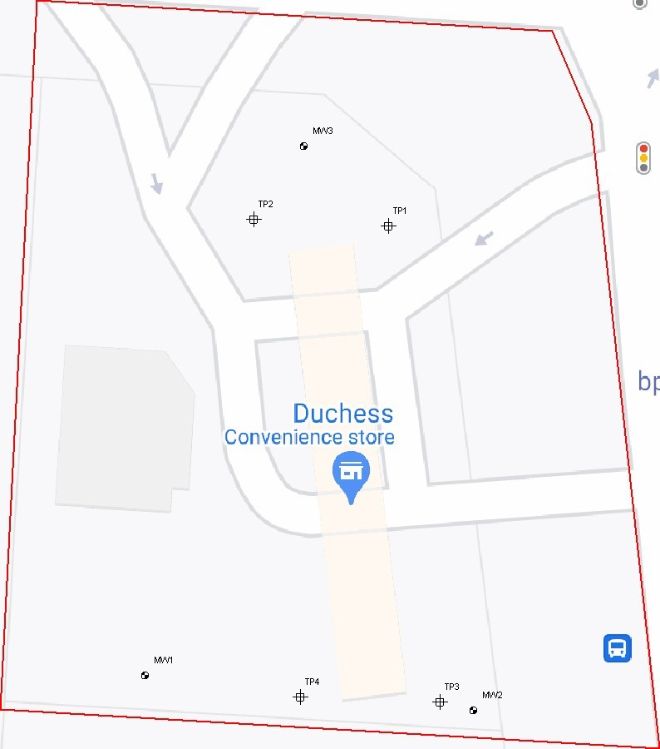
Project Location Map
Project Number:
PN123456
Project Name:
No Name Gas
Client Name:
ACME Oil and Gas
Site Location
Address:
625
Hillliard Rome Rd.
City:
Columbus
State:
Ohio
Engineer:
Date:
2022-11-09
Plan B Environmental
366
N 6th Street
Columbus, OH

Figure 2: Aerial Photographs

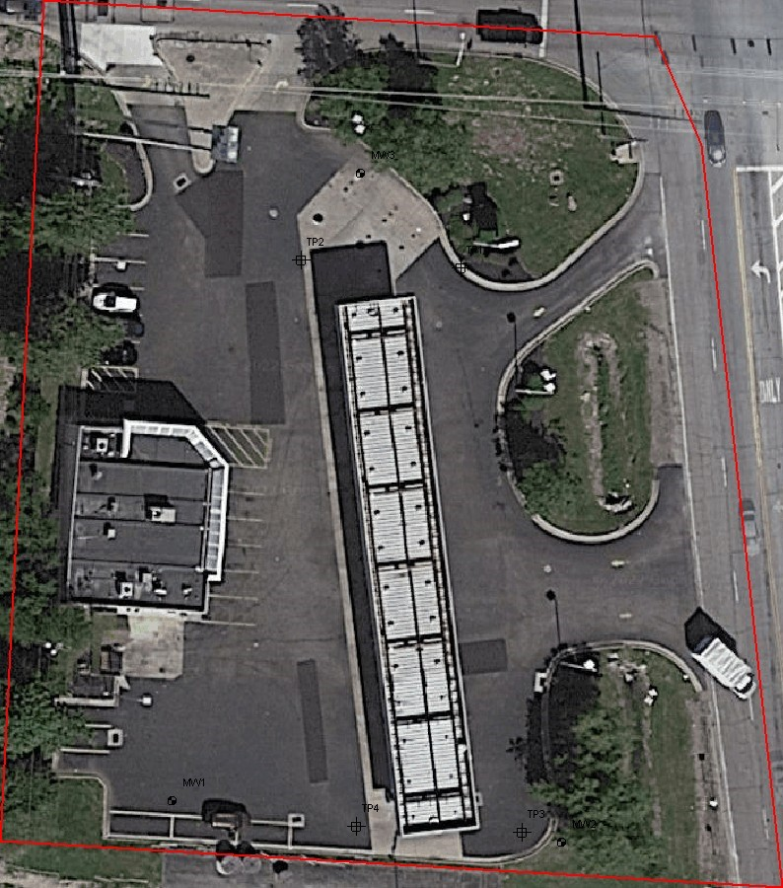
Project Location Map
Project Number:
PN123456
Project Name:
No Name Gas
Client Name:
ACME Oil and Gas
Site Location
Address:
625
Hilliard Rome Rd
City:
Columbus
State:
Ohio
Engineer:
Date:
2022-11-09
Plan B Environmental
366
N 6th Street
Columbus, OH

APPENDIX X1: SUBSURFACE EXPLORATION LOGS

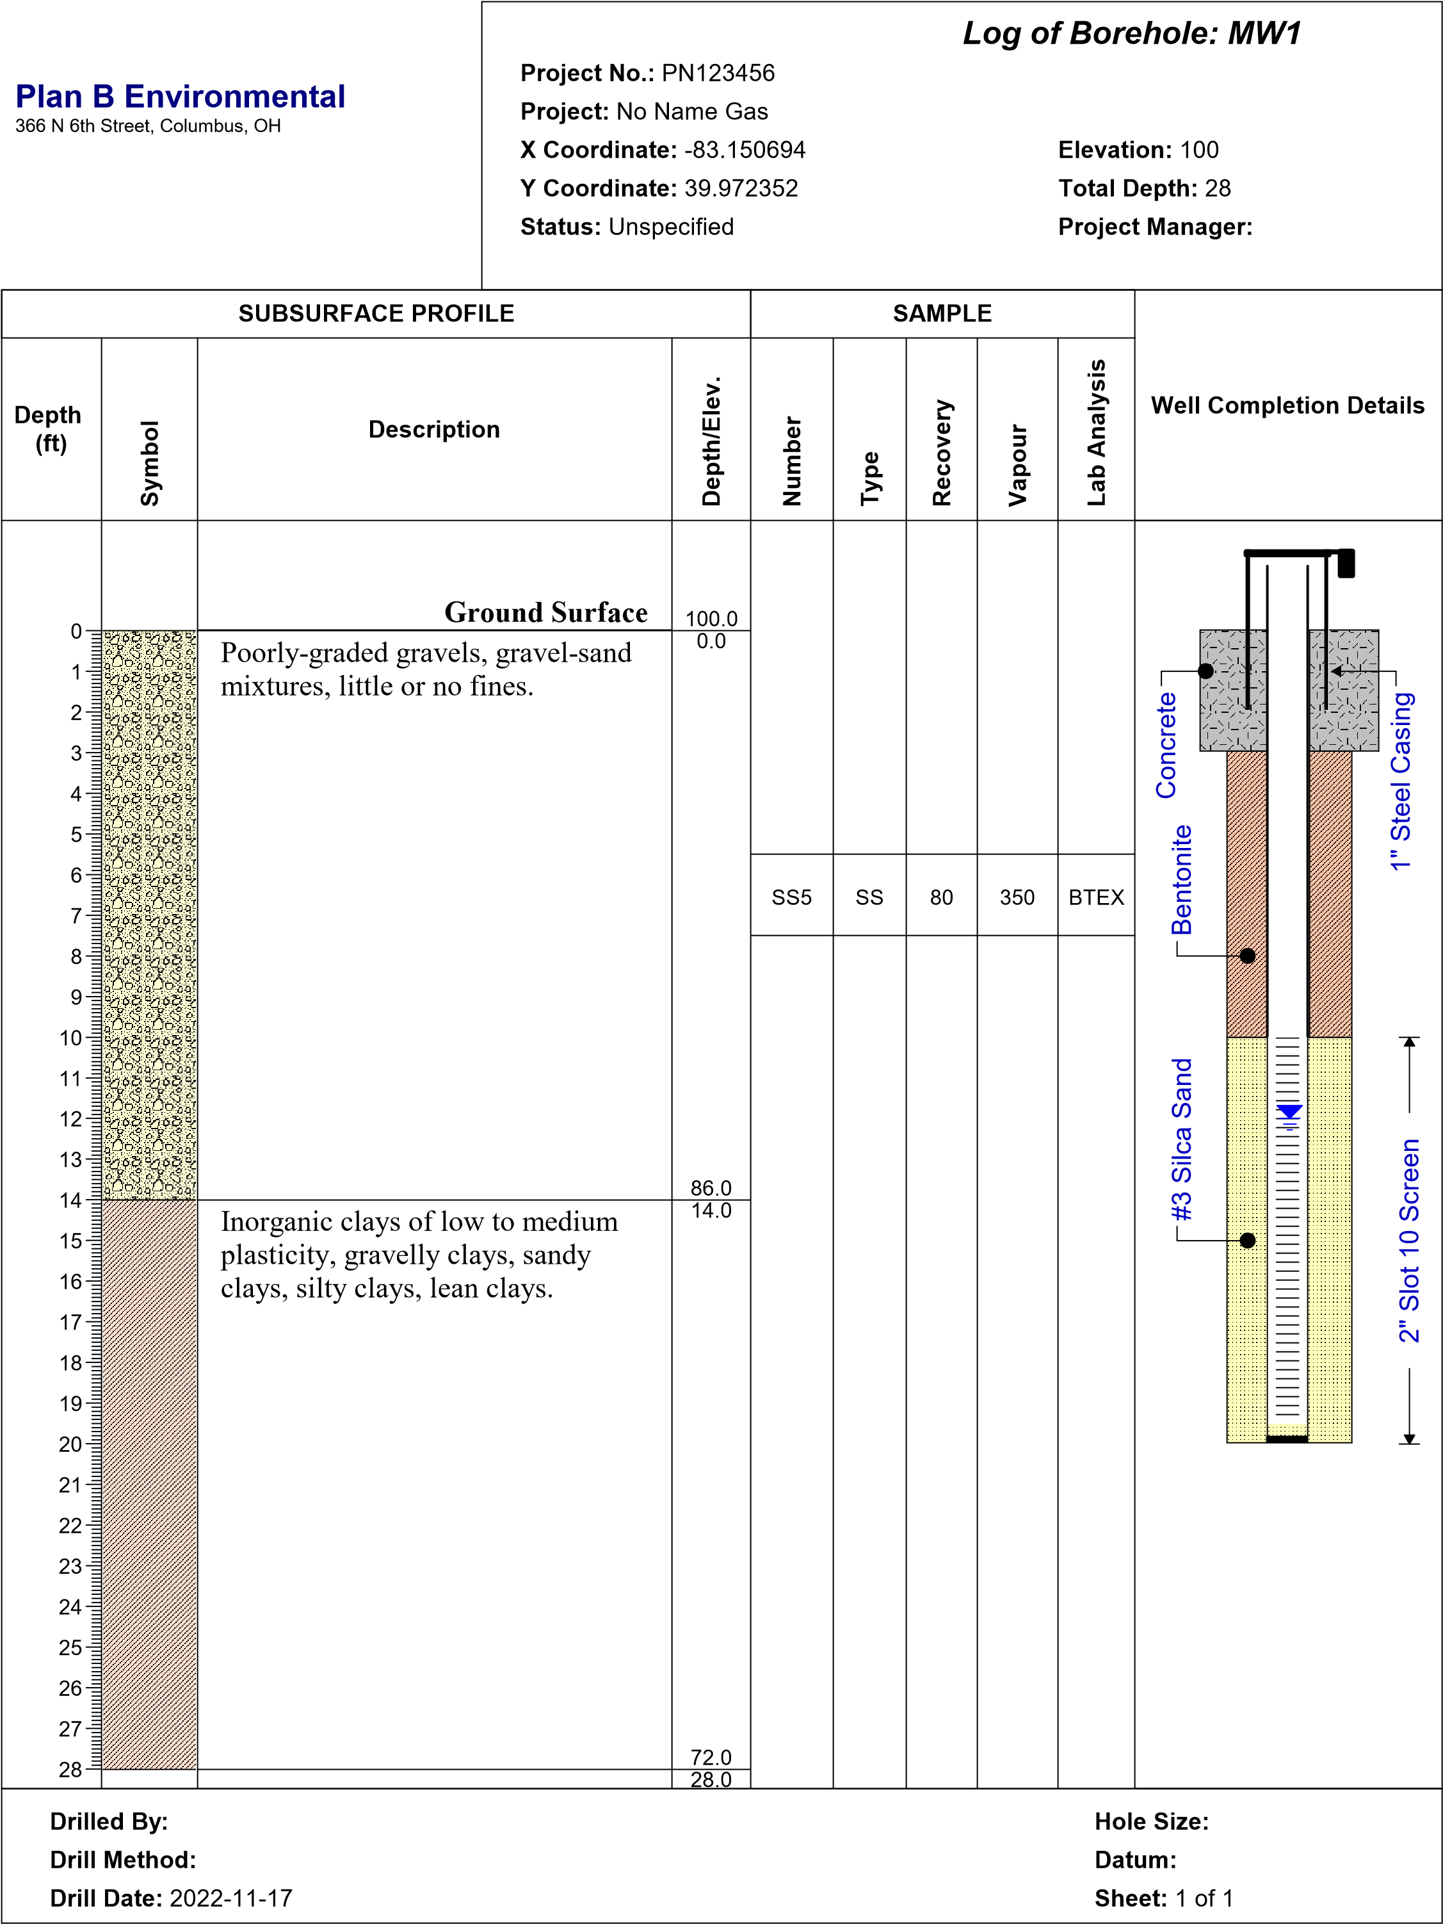


Log of Borehole:
Project No.:
Project:
X Coordinate:
Y Coordinate:
Status:
Elevation:
Total Depth:
Project Manager:
Drilled By:
Drill Method:
Drill Date:
Hole Size:
Datum:
Sheet:
1 of 2
Plan B Environmental
366
N 6th Street, Columbus, OH
Depth
)
ft
(
0
1
2
3
4
5
6
7
8
9
10
11
12
13
14
15
16
17
18
19
20
21
22
23
24
25
26
27
28
Symbol
Description
Depth/Elev.
Number
Type
Recovery
Vapour
Lab Analysis
Well Completion Details
SUBSURFACE PROFILE
SAMPLE
MW2
PN123456
No Name Gas
-83.150226
39.972314
Unspecified
100
32
Ground Surface
Poorly-graded gravels, gravel-sand
mixtures, little or no fines.
Inorganic clays of low to medium
plasticity, gravelly clays, sandy
clays, silty clays, lean clays.
100.0
0.0
85.0
15.0
SS6
SS
80
420
BTEX
2
" Slot 10 Screen
#3 Silca Sand
Bentonite
" Steel Casing
1
Concrete
1899-12-30
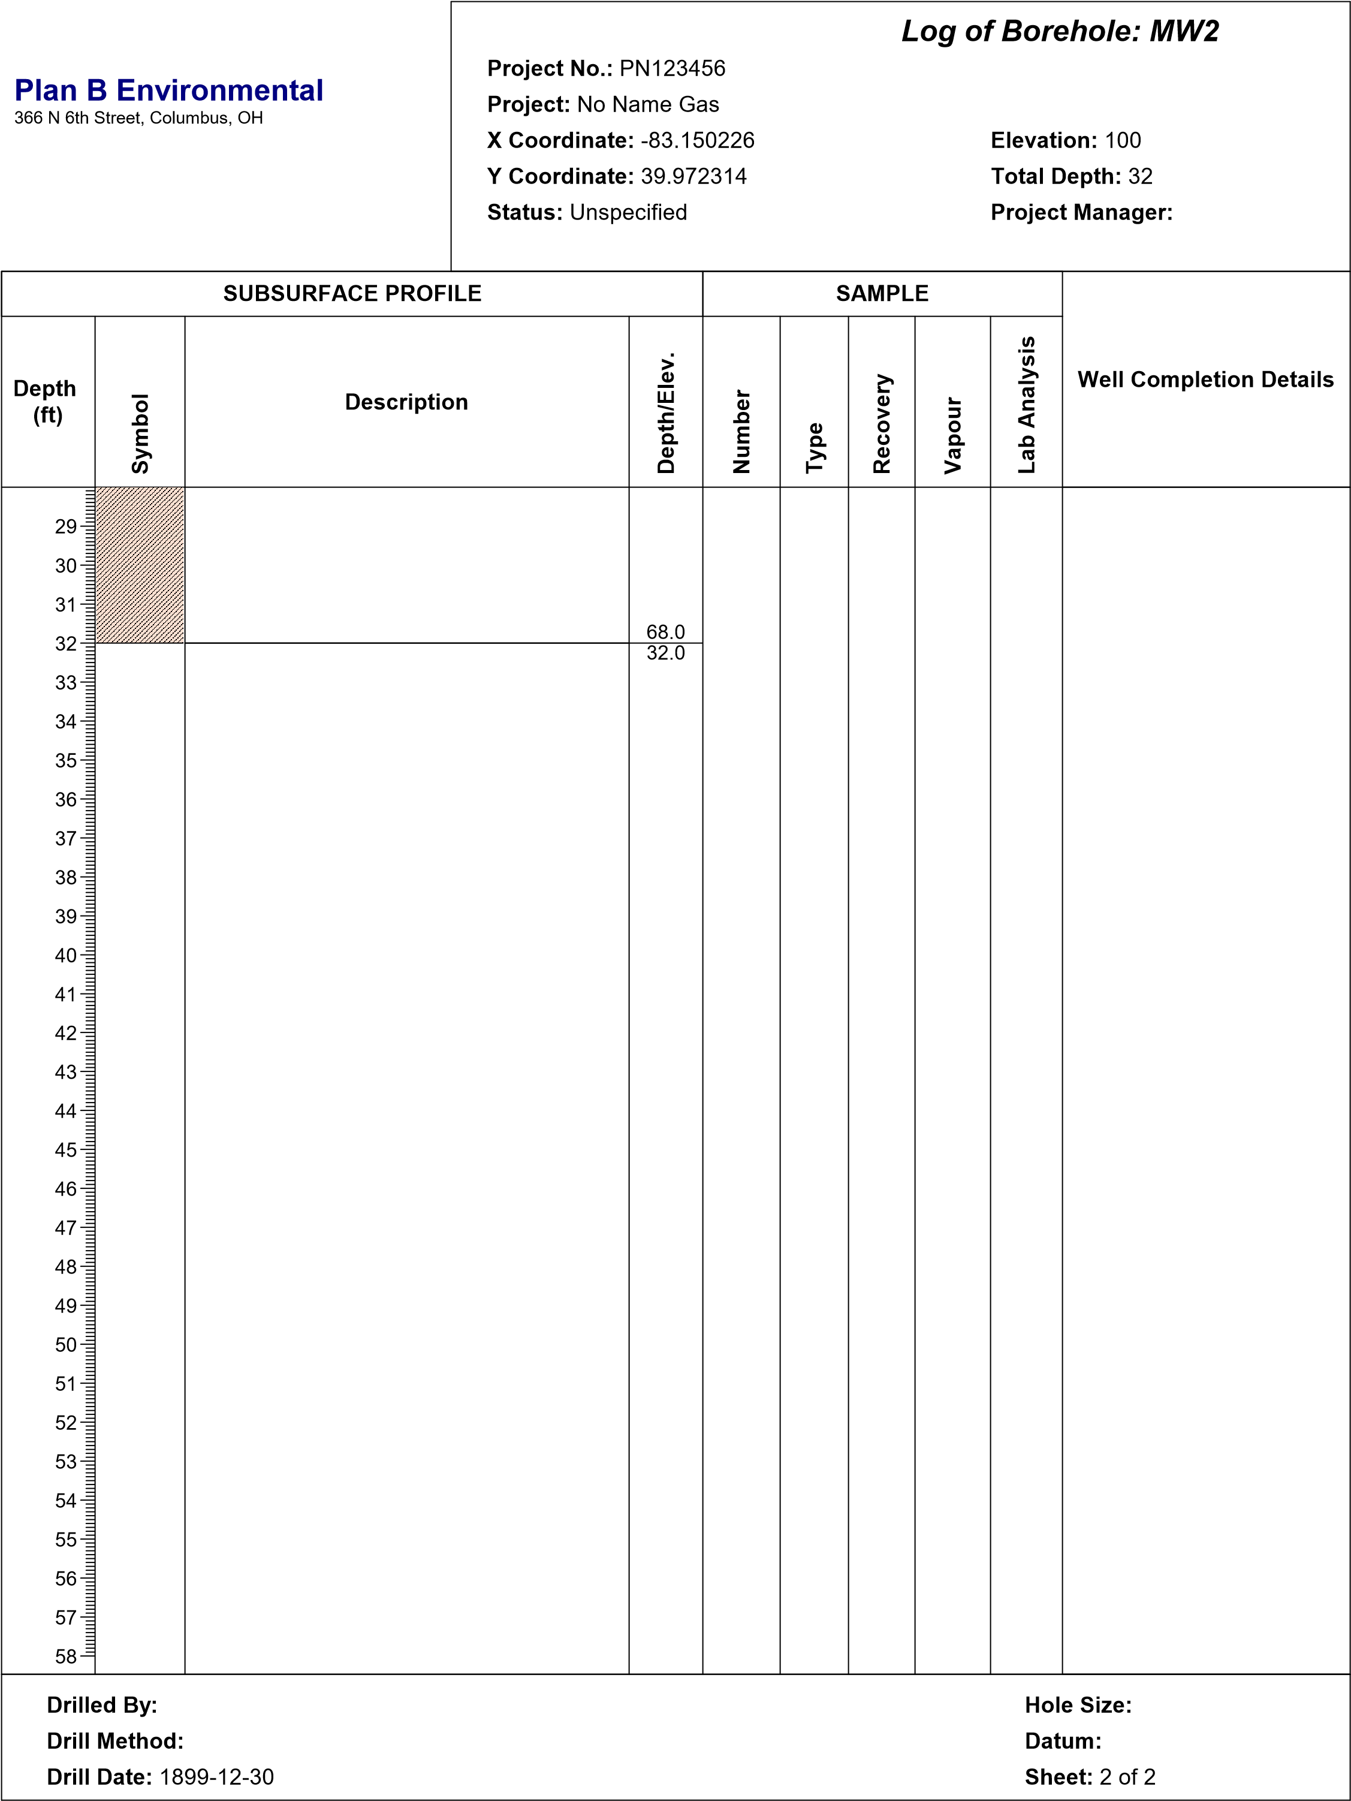

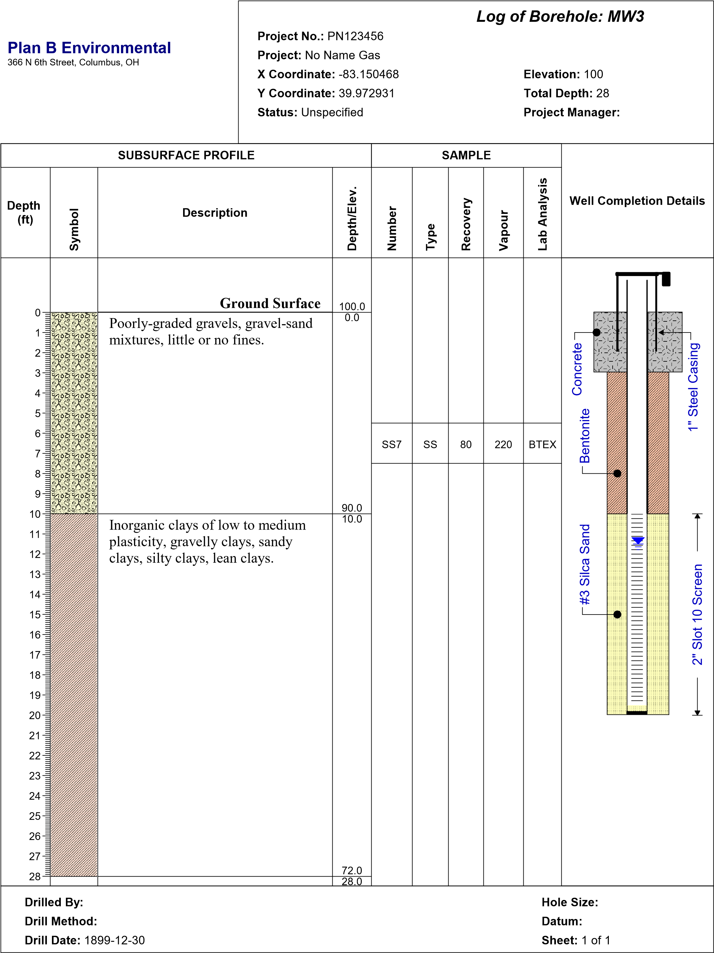

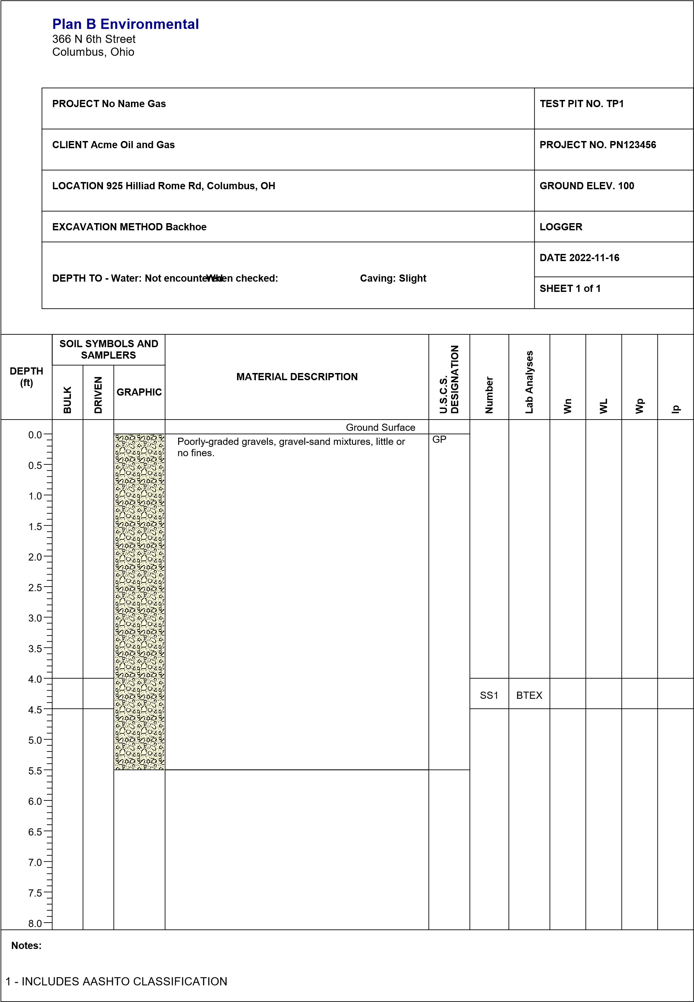

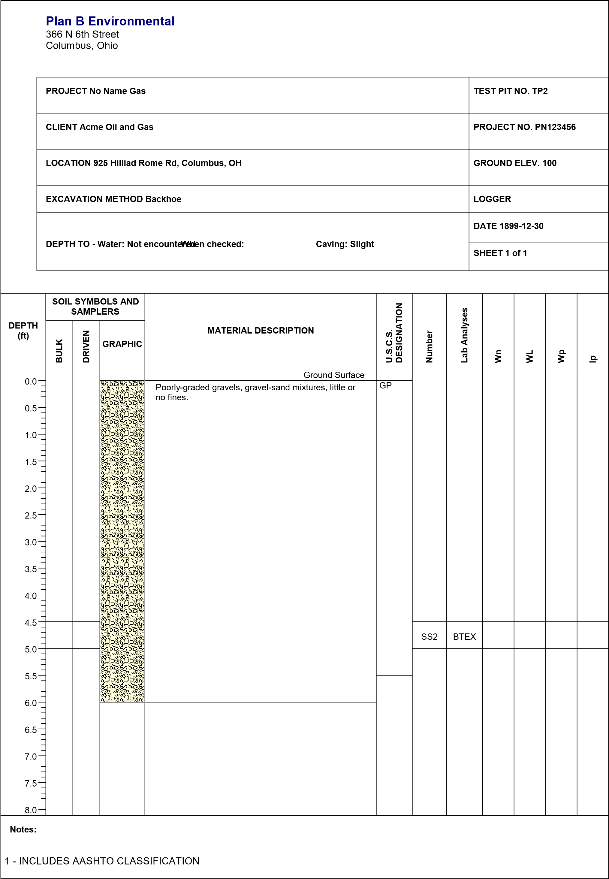

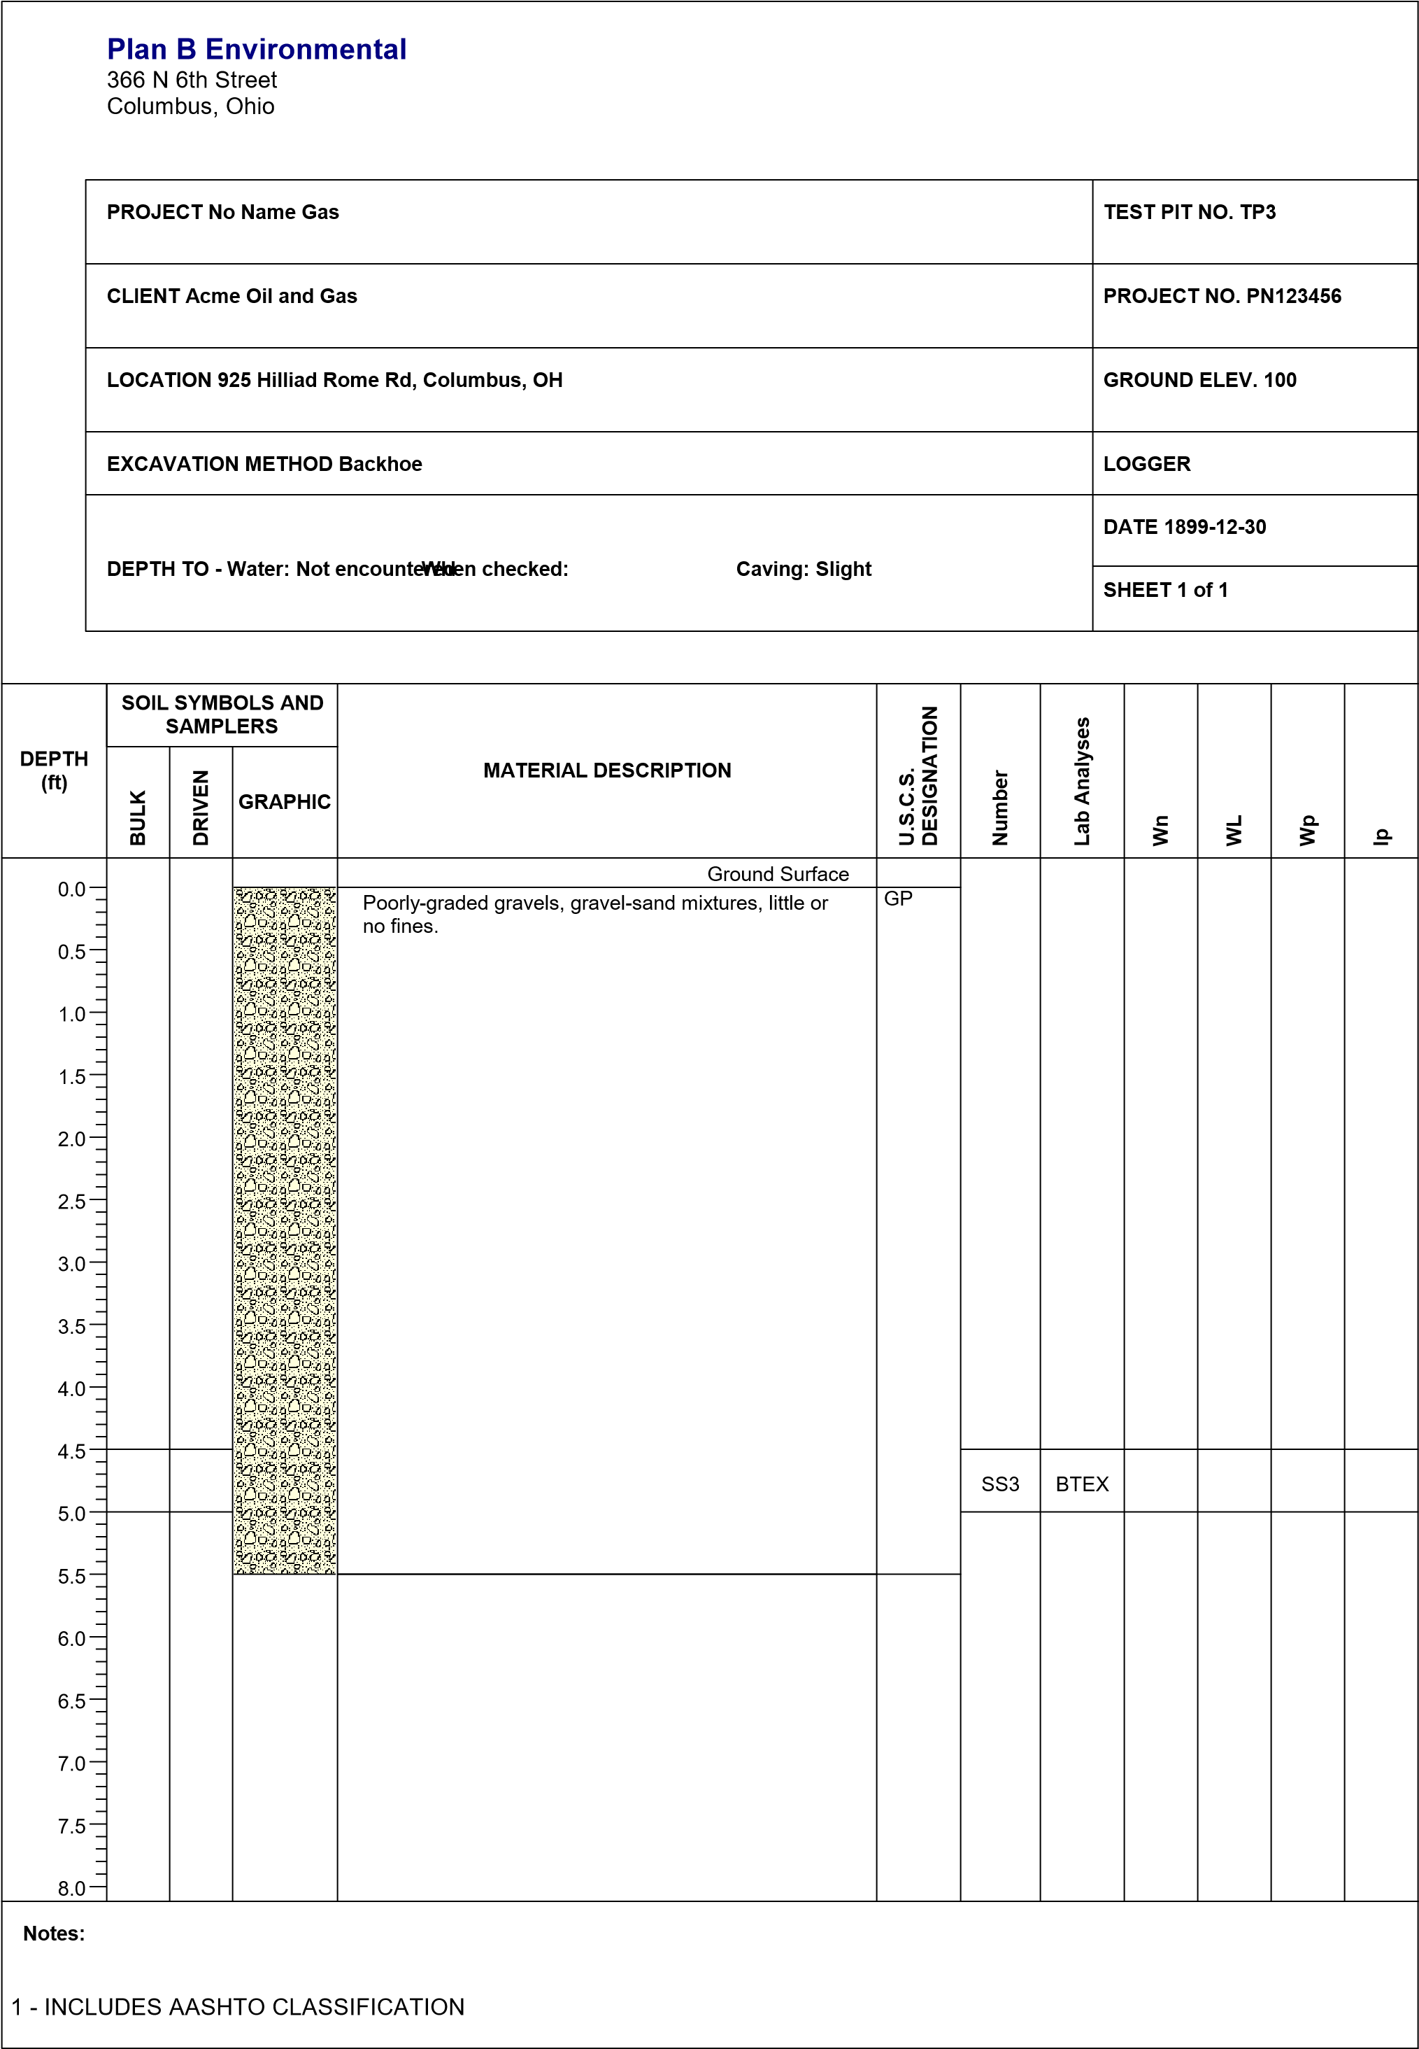
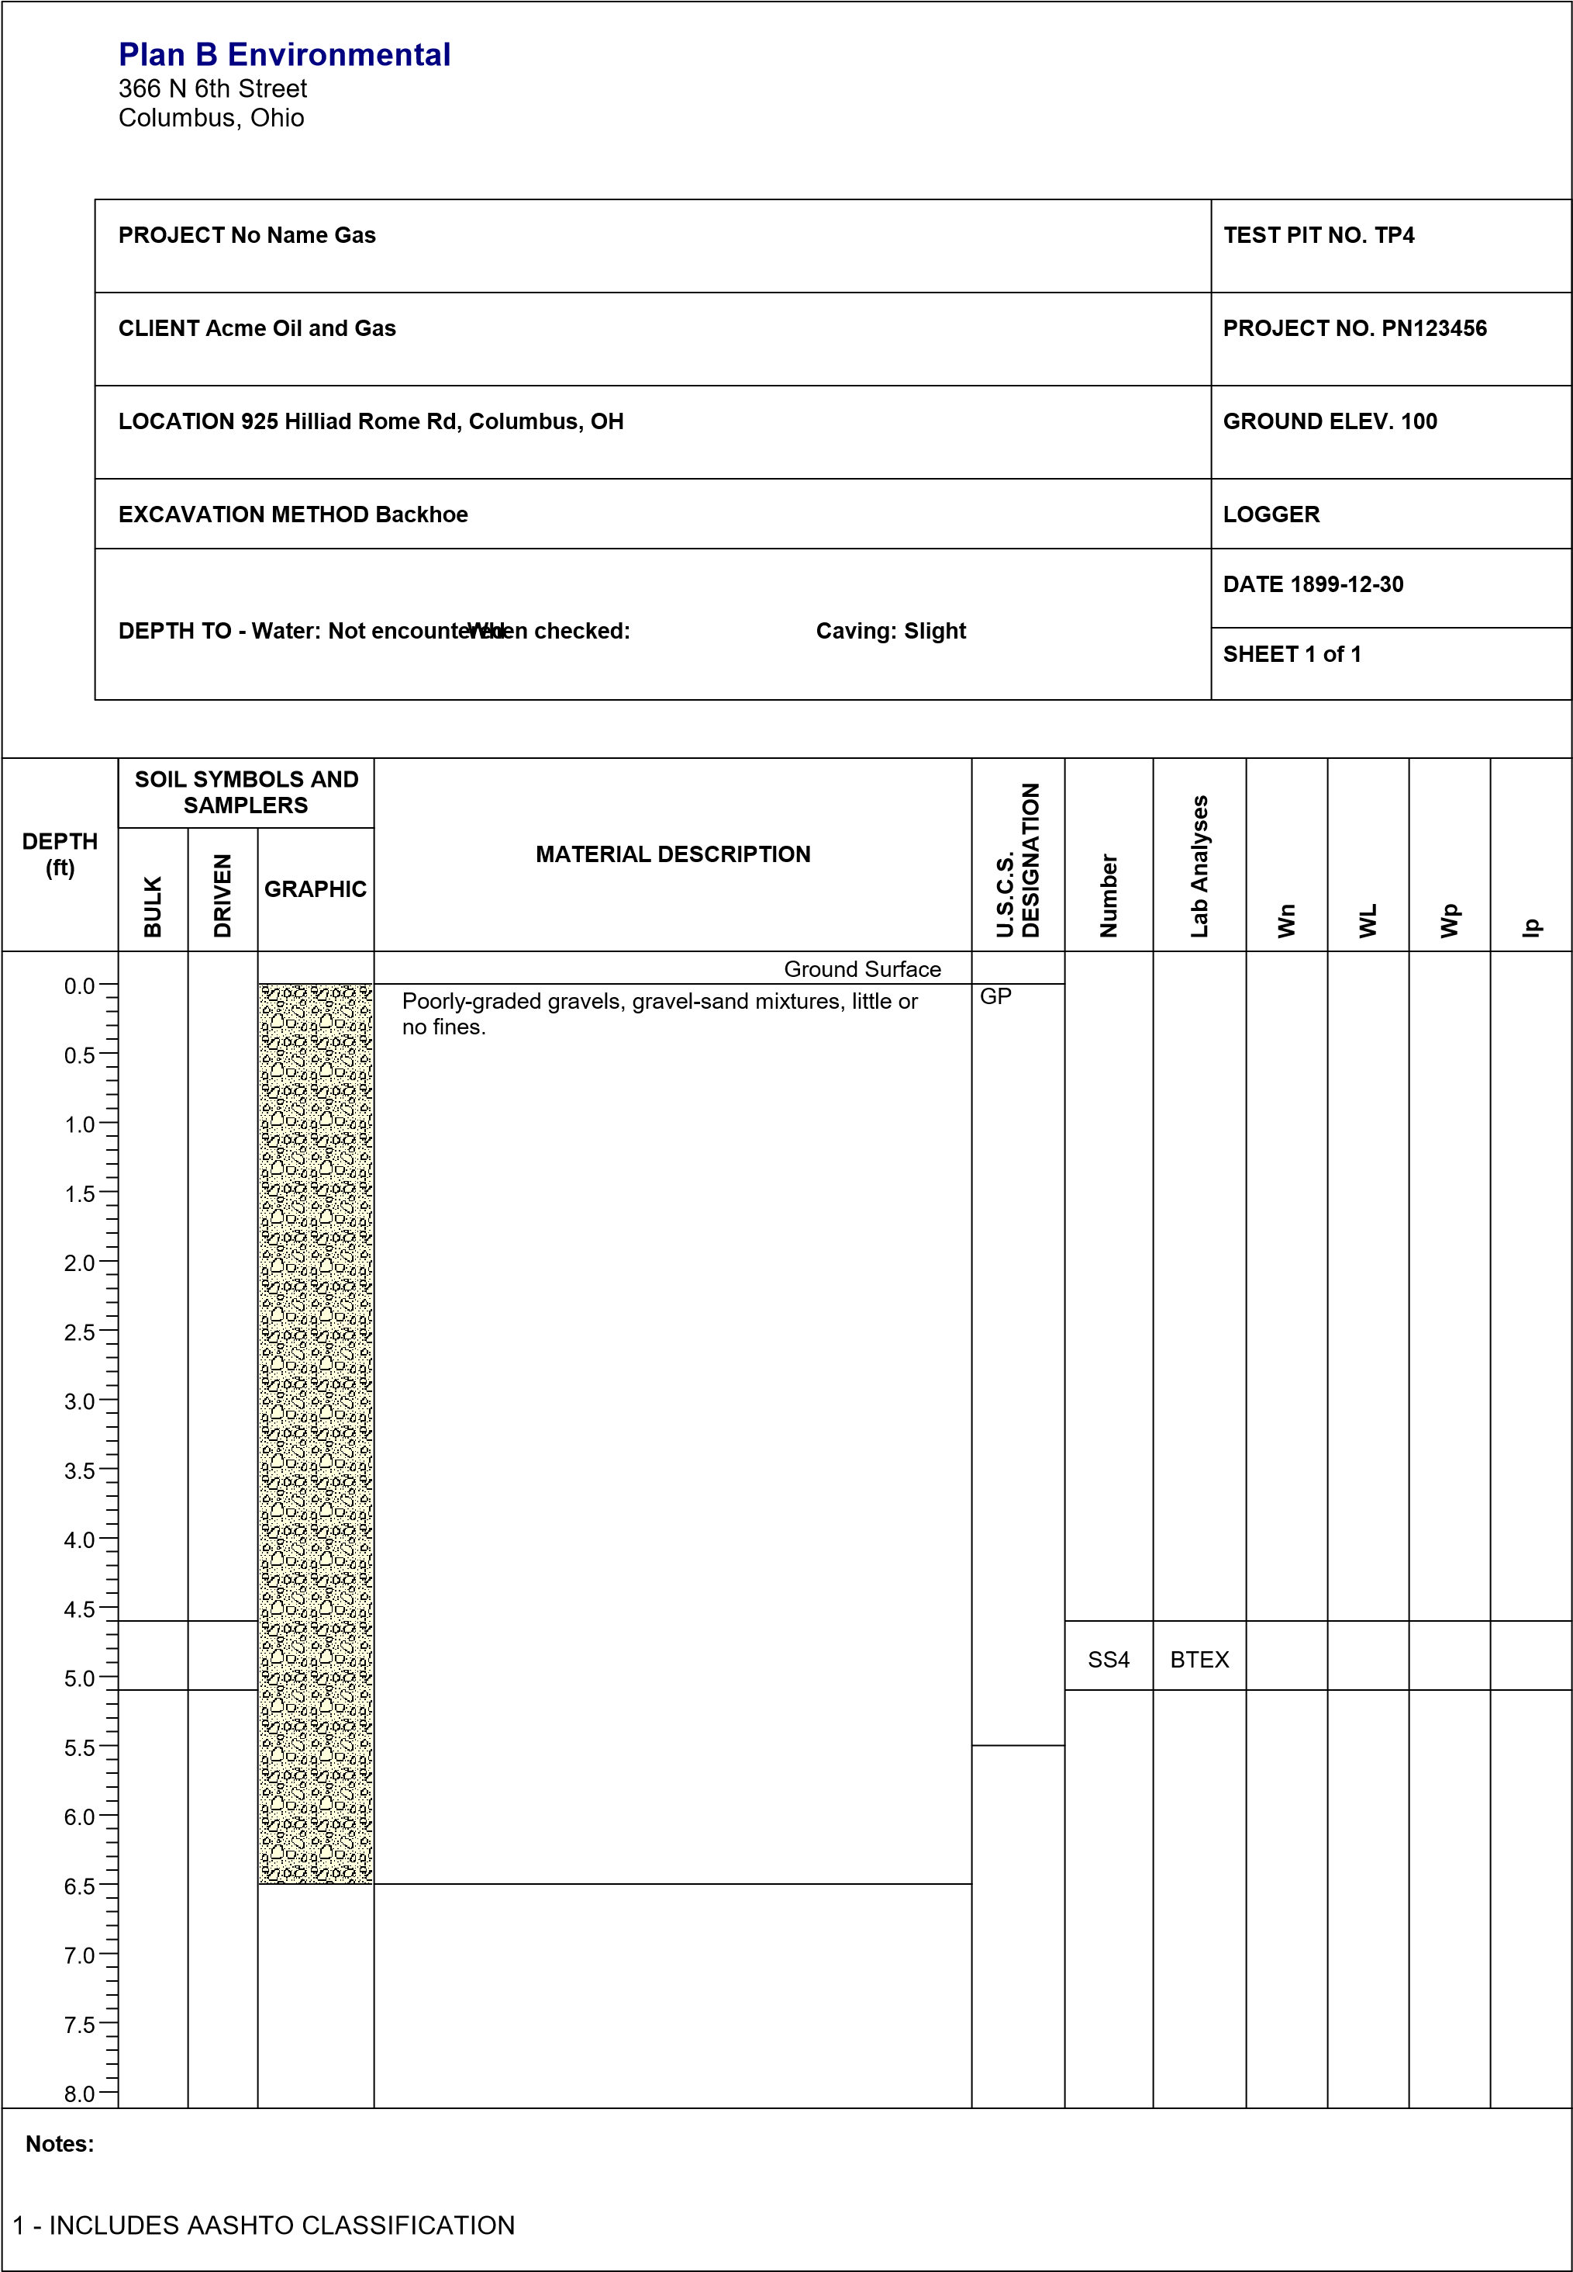

APPENDIX X2: LABORATORY REPORTS

APPENDIX X3: OTHER INFORMATION

